*Florida International University*

*School of Computing and Information Sciences*

Software Engineering Focus

Final Deliverable

Project Title: *Machine Learning for Small Business Merchandising*

**Team Members: Sephora Jean-Mary and Charlie Ramirez**

**Product Owner(s)**: Michael Balazs, Joe Garner

**Mentor(s)**: Ali Zaidi

**Instructor**: Masoud Sadjadi

The MIT License (MIT)

Copyright (c) *2016 Florida International University*

Permission is hereby granted, free of charge, to any person obtaining a copy of this software and associated documentation files (the "Software"), to deal in the Software without restriction, including without limitation the rights to use, copy, modify, merge, publish, distribute, sublicense, and/or sell copies of the Software, and to permit persons to whom the Software is furnished to do so, subject to the following conditions:

The above copyright notice and this permission notice shall be included in all copies or substantial portions of the Software.

THE SOFTWARE IS PROVIDED "AS IS", WITHOUT WARRANTY OF ANY KIND, EXPRESS OR IMPLIED, INCLUDING BUT NOT LIMITED TO THE WARRANTIES OF MERCHANTABILITY, FITNESS FOR A PARTICULAR PURPOSE AND NONINFRINGEMENT. IN NO EVENT SHALL THE AUTHORS OR COPYRIGHT HOLDERS BE LIABLE FOR ANY CLAIM, DAMAGES OR OTHER LIABILITY, WHETHER IN AN ACTION OF CONTRACT, TORT OR OTHERWISE, ARISING FROM, OUT OF OR IN CONNECTION WITH THE SOFTWARE OR THE USE OR OTHER DEALINGS IN THE SOFTWARE.

***Abstract***

*As our society enters a new industrial revolution, powered by artificial intelligence (ai) and machine learning, people of all professions will be affected. Regardless of who you are, ai will most likely find a way into your daily life. Therefore, being prepared for these changes is crucial.*

*This document presents the information necessary to gain a good understanding of the process we went through to build our project “ai for all”. Design choices, components, and work done by all team members will be presented. Additionally, we will present the reasoning behind many of the decisions we took and give you an idea of how this project can help people of all ages and professions.*

**Table of Contents**

**Introduction** …………………………………………………………………………………………….....5

Current System ……….…………………………………………………………………………………………………..5

Purpose of New System …………………………………………………..……………………………. 5

**User Stories**

Implemented User Stories ………………………………………….…………………………………..7

Pending User Stories …………………………………………………………………...………………………………..….. 10

**Project Plan**

Hardware and Software Resources ……………………………………………………………….… 12

Sprints Plan ……………………………………………………………..………………………………………………………. 13

*Sprint 1*  …………………………………………………………………………………………………………………………... 13

*Sprint 2*  …………………………………………………………………………………………………………………………... 13

*Sprint 3*  …………………………………………………………………………………………………………………………... 14

*Sprint 4*  …………………………………………………………………………………………………………………………... 15

*Sprint 5*  …………………………………………………………………………………………………………………………... 16

*Sprint 6*  …………………………………………………………………………………………………………………………... 17

*Sprint 7*  …………………………………………………………………………………………………………………………... 18

**System Design**

Architectural Patterns ………………………………………………………………………………………………….. 20

System and Subsystem Decomposition …………………………………………………………………………….… 21

Deployment Diagram …………………………………………………………………………………………………….…... 22

Design Patterns ………………………………………………………………………………………………………….….... 22

**System Validation**  …………………………………………………………………………………………………………………….23

**Glossary**  ………………………………………………………………………………………………………………………………….37

**Appendix**  ………………………………………………………………………………………………………………………………….38

Appendix A - UML Diagrams ………………………………………………………………………………………………. 38

*Static UML Diagrams*  ……………………………………………………………………………………………………….38

*Dynamic UML Diagrams*  …………………………………………………………………………………………………..40

Appendix B - User Interface Design …………………………………………………………………………….…... 52

Appendix C - Sprint Review Reports …………………………………………………………………………...…… 69

Appendix D - User Manuals, Installation/Maintenance Document, Shortcomings/Wishlist Document and other documents …………………………………………………………………….…………… 74

**References** ……………………………………………………………………………………………………………………...………...80

# Introduction

This project, which we have given the short name of **ai for all**, serves two functions. The first function is as a teaching tool for concepts such as artificial intelligence and machine learning that many have difficulty understanding. As we enter this new era of machine learning, we will find that more and more of the tools we use will have something to do with machine learning. We want **everyone**, regardless of their age or profession, to have at their fingertips tools to help them understand seemingly difficult concepts such as these.

Although we find the idea of *teaching* to be of extreme importance, we wanted our project to be more than just a teaching tool. We wanted to show off the power of not only machine learning, but also of ways in which machine learning could be paired with other technologies to create something powerful. Therefore, our project serves a secondary function: an opensource tool for merchandisers and consumers to *collect* and *analyze* data from the web.

## Current System

We began this project with an *empty slate*. There was no previous version to this project. Therefore, the entire deliverable was completed during the span of one semester.

## Purpose of New System

The first and currently only version of this project serves the purpose of helping others gain understanding of difficult concepts such as machine learning, teaching them the importance of acquiring this knowledge, and allowing them to see *firsthand* the power such tools can hold. Our code is opensource with the purpose of allowing others to clone our work, change it to fit other needs if they so desire, and *build on it*.

The system is composed of 3 primary parts:

1. A web scraper, used to collect data from the web. For this version of *ai for all,* we decided to collect data from the world’s largest online retailer **Amazon.com**.

2. A website, www.itsaiforall.com (alternatively <https://aiforall.herokuapp.com/>), where our teaching tool resides. The website serves the function of introducing our brand as well as guiding users through our different tools.

3. A web app built using **Anvil** which serves the function of allowing our tool to be *dynamic* and adapt to the needs of individual users.

# User Stories

The following section provides the detailed user stories that were implemented in this iteration of the …. project. These user stories served as the basis for the implementation of the project’s features. This section also shows the user stories that are to be considered for future development.

## Implemented User Stories

**User Story 1**: As a developer, I need to come up with a viable lesson plan for a machine learning lesson.

*Acceptance Criteria*

* The lesson plan must have a complete layout of all the topics that are to be discussed.
* The lesson plan must include key ideas and terms to be discussed.
* The lesson plan is to be coded in a Jupyter Notebook.

**User Story 2**: As a developer, I need to learn the necessary technologies required for effective machine learning programming.

*Acceptance Criteria*

* Learn about linear regression.
* Learn about logistic regression.
* Learn about the three main machine learning methods: supervised, unsupervised, and reinforcement learning.

**User Story 3**: As a developer, I want to code the web scraper that we will use to collect data from Amazon web pages.

*Acceptance Criteria*

* The web scraper will at this point have a basic layout and be able to run on a local server.
* It must be able to scrape at least one attribute.

**User Story 4**: As a User, I want to be able to see product information of various Amazon products.

*Acceptance Criteria*

* The user is able to see attributes of multiple products collected by the web scraper.

**User Story 5**: As a developer, I need to refine the web scraper so that it will scrape amazon for more product information.

*Acceptance Criteria*

* The scraper can collect at least 5 attributes: product title, product price, product rating, number of reviews, and product description.

**User Story 6**: As a developer, I need to fix the web scraper so that it will skip over tags that are not available.

*Acceptance Criteria*

* The web scraper will not crash if it doesn’t find an attribute.
* The web scraper will return an empty value if it doesn’t find an attribute.

**User Story 7**: As a developer, I need to start a website to display information from the web scraper.

*Acceptance Criteria*

* Have 5 html files that explain various components of the project.
* Style the html file with a corresponding css file.

**User Story 8**: As a developer, I need to have a front page to the website explaining what the purpose of this project is.

*Acceptance Criteria*

* The first html file, our home page, explains the purpose of our project and links to subsequent web pages.

**User Story 9**: As a developer, I need to incorporate a navigation bar onto the website.

*Acceptance Criteria*

* Each page in the website has a navigation bar that allows for a user to find each page.

**User Story 10**: As a developer, I would like to create a search engine functionality within the web scraper such that it allows a user to search for a term of their choice.

*Acceptance Criteria*

* The anvil web app has a search option.
* Once submitted, the web scraper will run in the background and output the results.

**User Story 11**: As a developer, I would like to allow the web crawling spider to be flexible and find multiple attributes of products.

*Acceptance Criteria*

* The web crawler will return many more attributes from amazon products.
* Each return is displayed to the user.

**User Story 12**: As a developer, I would like to use the bootstrap library to help set up a responsive and beautiful website.

*Acceptance Criteria*

* Use the bootstrap library in aiding the responsiveness of our website.
* Use the bootstrap library in some styling aspects of the website.

**User Story 13**: As a developer, I would like to include multiple pages in the website that allow the user to see and experience our product.

*Acceptance Criteria*

* The website includes the 3 main component pages.
* The website includes a home page.
* The website includes a “more info” page.

**User Story 14**: As a User, I want to be able to experience the product in a way that captures my attention and keeps me interested.

*Acceptance Criteria*

* The home page and three main content pages are welcomed by an interesting video that loops.
* The pages include interesting images.
* Icons are used throughout the website.

**User Story 15**: As a developer, I want to be able to clean the data that we scrape from the web.

*Acceptance Criteria*

* The data collected from the web scraper is removed of symbols.
* The data collected is in the correct data type.

**User Story 17**: As a developer, I want to complete the development of a web scraper that allows me to crawl the web.

*Acceptance Criteria*

* The web scraper is rid of all bugs.

**User Story 19**: As a developer, I want to code the website to display the results of our project through visual representations.

*Acceptance Criteria*

* The machine learning page includes a dropdown that displays various data visualization models.
* The dropdown includes a variety of model options.

**User Story 20**: As a developer, I would like to complete the website layout so that it has interactive html and css.

*Acceptance Criteria*

* The navigation bar is rid of bugs.
* The web scraper page includes a dropdown that allows users to select a dataset.

**User Story 21**: As a developer, I would like to set up flask framework.

*Acceptance Criteria*

* Flask dependencies are installed.
* Flask environment is set up.

**User Story 22**: As a developer, I would like to transfer all files to flask framework.

*Acceptance Criteria*

* All the files are transferred to our flask environment.

**User Story 24**: As a user, I want to be able to access the Anvil web app in various ways from the website.

*Acceptance Criteria*

* Include various links in relevant places that allow a user to navigate to the web app.
* Include a frame of the web app in the “dynamic visualizations” page that a user can interact with.

**User Story 25**: As a developer, I would like to upload data from csv files into anvil web app.

*Acceptance Criteria*

* The csv files are scraper using the web scraper.
* The web app allows the files to be incorporated/read.

**User Story 27**: As a developer, I would like to implement the web scraper into the anvil web app so that a user can see the web scraper in action.

*Acceptance Criteria*

* The back end of the web app incorporates the web scraper.
* A user can input a term using the front end.

**User Story 28**: As a developer, I would like to scrape more fields from the amazon website page.

*Acceptance Criteria*

* The amazon web page is analyzed for patterns among various products.
* The web scraper incorporates attributes such as ASIN number or days since first listed on amazon.

**User Story 29**: As a developer, I would like to create multiple datasets for the website.

*Acceptance Criteria*

* The web scraper is used to scrape additional types of products.
* The scraped datasets are transferred to the flask environment and used in the “web scraper” page.

**User Story 31**: As a developer, I would like to create a search functionality in the Anvil App that runs the scraper from the local host.

*Acceptance Criteria*

* The anvil app successfully scrapes product information from the amazon site.
* The back end of the web scraper runs without bugs in the anvil web app.

**User Story 32**: As a developer, I would like to return scraped data directly from web scraper into Anvil database after clearing previous data.

*Acceptance Criteria*

* The data that has been cached is removed.
* New data can take its place.

**User Story 33**: As a developer, I would like to display the data (from select attributes) on the same page as the product search box in the Anvil web app.

*Acceptance Criteria*

* The anvil web app allows us to display the results of the web scraper on the search term input by the user.
* The results are displayed in the same page as the product search box.

**User Story 34**: As a developer, I would like to complete functionalities in the flask app so that the website runs smoothly for users.

*Acceptance Criteria*

* The website can run without any errors or bugs.
* The website is ready to be hosted on a web server.

**User Story 35**: As a developer, I would like to host the flask app on the Heroku platform.

*Acceptance Criteria*

* The entire flask app is pushed to Heroku.
* The website is hosted on a web server that can be accessed at any time.

**User Story 36**: As a developer, I would like to create visualizations using seaborn and matplotlib.

*Acceptance Criteria*

* Various data visualization tools are used to improve the quality of our models.
* User experience increases in quality as a result.

**User Story 37**: As a user, I would like to be able to view these visualizations on the web app in a clear and easy to work with interface.

*Acceptance Criteria*

* The anvil web app allows a user to see the models in an interactive interface.
* The interface runs without any bugs.

**User Story 38**: As a developer, I would like to create real time bar, pie, and scatter plot visualizations on anvil.

*Acceptance Criteria*

* The anvil app incorporates bar charts, pie charts, and scatterplots.

**User Story 39**: As a developer, I would like to create a correlation matrix using z scores with the use of plotly package on anvil.

*Acceptance Criteria*

* Install the plotly package.
* Use the package to create a correlation matrix.
* Display the matrix on the anvil app.

**User Story 40**: As a developer, I would like to host the anvil web app on a web server from git so that the user can access the link.

*Acceptance Criteria*

* Host the anvil app on a web server where it will always be running.

## Pending User Stories

**User Story 16**: As a developer, I want to store the data we scrape into a database.

* We decided to store scraped data on json and csv files instead of a database. This was done so because, unlike the Anvil web app models, the models on the website are not meant to be dynamic.

**User Story 18**: As a developer, I want to have a database full of relevant data that is clean and ready for modeling.

* This user story was partly completed in the sense that our data is clean and ready for modeling but not stored in a database.

**User Story 23**: As a developer, I would like to connect the web scraper to the website via flask.

* While this solution would be ideal, we decided to connect the web scraper to our Anvil web app instead of connecting it to the website. This was done because it was difficult to find a solution and time was of the essence.

**User Story 30**: As a developer, I would like to create another page on the Anvil website to showcase ways for AI to be implemented in other fields.

* This is a great idea and a work in progress.

# Project Plan

This section describes the planning that went into the realization of this project. This project incorporated the agile development techniques and as such required the sprints to be planned. These sprint plannings are detailed in the section. This section also describes the components, both software and hardware, chosen for this project.

## Hardware and Software Resources

The following is a list of all hardware and software resources that were used in this project:

**Virtual Studio Code**

* Our code editor of choice

**Jupyter Notebooks**

* We used Jupyter a lot, especially at the beginning of the semester, for the machine learning lesson. However, further on we decided to make the lesson into a website and Jupyer became the place where we tested and ran our visual models.

**Anvil**

* Anvil is the service we used to build our dynamic web app. It allowed us to host a variety of visual models and gave our project dynamic content.

**Flask**

* Flask is the python-based web framework we used for our website.

**Bootstrap**

* We used the Bootstrap 4 library to help us build part of the website (specifically the nav bar and a few other minor things such as spacing and round images).

***Programming Languages Used***

* HTML5: For coding our *website*
* CSS3: For styling our *website*
* JavaScript: For functionality in our *website*
* Python: We used python in the *Jupyter* *notebooks*, in *Flask*, *Anvil*, and to create our *web* *scraper*.

## 

## 

## Sprints Plan

### Sprint 1

*January 13th – January 26th*

***Total Stories***

* **User Story 1**: As a developer, I need to come up with a viable lesson plan for a machine learning/game theory lesson.
* **User Story 2**: As a developer, I need to learn the necessary technologies required for effective machine learning programming.

**Sephora Jean-Mary**

* **User Story 1**: As a developer, I need to come up with a viable lesson plan for a machine learning/game theory lesson.
* **User Story 2**: As a developer, I need to learn the necessary technologies required for effective machine learning programming.

**Charlie Ramirez**

* **User Story 1**: As a developer, I need to come up with a viable lesson plan for a machine learning/game theory lesson.
* **User Story 2**: As a developer, I need to learn the necessary technologies required for effective machine learning programming.

***Sprint Review***

**Attendees**: Sephora Jean-Mary, Charlie Ramirez, Ali Zaidi, Joe Garner, Naz Huq

**Date**: January 24th, 2020

**Start Time**: 12:30pm

**End Time**: 1:30pm

The following stories were accepted after the approval of the PO during the sprint review:

* **User Story 1**: As a developer, I need to come up with a viable lesson plan for a machine learning/game theory lesson. **Finished**
* **User Story 2**: As a developer, I need to learn the necessary technologies required for effective machine learning programming. **Finished**

This first sprint for us was very chaotic. When we chose the project, we were put in touch with Michael Balazs, the original product owner. Our project was undecided until around the last day of the sprint, when the current team decided on the idea we ended up working on for the rest of the semester.

### Sprint 2

*January 27th – February 9th*

***Total Stories***

* **User Story 3**: As a developer, I want to code the web scraper that we will use to collect data from Amazon web pages
* **User Story 4**: As a User, I want to be able to see product information of various Amazon products.
* **User Story 5**: As a developer, I need to refine the web scraper so that it will scrape amazon for more product information.
* **User Story 6**: As a developer, I need to fix the web scraper so that it will skip over tags that are not available.
* **User Story 7**: As a developer, I need to start a website to display information from the web scraper.
* **User Story 8**: As a developer, I need to have a front page to the website explaining what the purpose of this project is.
* **User Story 9**: As a developer, I need to incorporate a navigation bar onto the website.

**Sephora Jean-Mary**

* **User Story 7**: As a developer, I need to start a website to display information from the web scraper.
* **User Story 8**: As a developer, I need to have a front page to the website explaining what the purpose of this project is.
* **User Story 9**: As a developer, I need to incorporate a navigation bar onto the website.

**Charlie Ramirez**

* **User Story 3**: As a developer, I want to code the web scraper that we will use to collect data from Amazon web pages.
* **User Story 4**: As a User, I want to be able to see product information of various Amazon products.
* **User Story 5**: As a developer, I need to refine the web scraper so that it will scrape amazon for more product information.
* **User Story 6**: As a developer, I need to fix the web scraper so that it will skip over tags that are not available.

***Sprint Review***

**Attendees**: Sephora Jean-Mary, Charlie Ramirez, Ali Zaidi, Joe Garner, Naz Huq

**Date**: February 6th, 2020

**Start Time**: 12:00pm

**End Time**: 12:30pm

The following stories were accepted after the approval of the PO during the sprint review:

* **User Story 3**: As a developer, I want to code the web scraper that we will use to collect data from Amazon web pages. **Finished**
* **User Story 4**: As a User, I want to be able to see product information of various Amazon products. **Finished**
* **User Story 7**: As a developer, I need to start a website to display information from the web scraper. **Finished**
* **User Story 8**: As a developer, I need to have a front page to the website explaining what the purpose of this project is. **Finished**
* **User Story 9**: As a developer, I need to incorporate a navigation bar onto the website. **Finished**

### Sprint 3

*February 10th – February 23rd*

***Total Stories***

* **User Story 10**: As a developer, I would like to create a search engine functionality within the web scraper such that it allows a user to search for a term of their choice.
* **User Story 11**: As a developer, I would like to allow the web crawling spider to be flexible and find multiple attributes of products.
* **User Story 12**: As a developer, I would like to use the bootstrap library to help set up a responsive and beautiful website.
* **User Story 13**: As a developer, I would like to include multiple pages in the website that allow the user to see and experience our product.
* **User Story 14**: As a User, I want to be able to experience the product in a way that captures my attention and keeps me interested.
* **User Story 15**: As a developer, I want to be able to clean the data that we scrape from the web.
* **User Story 16**: As a developer, I want to store the data we scrape into a database.

**Sephora Jean-Mary**

* **User Story 14**: As a User, I want to be able to experience the product in a way that captures my attention and keeps me interested.
* **User Story 15**: As a developer, I want to be able to clean the data that we scrape from the web.
* **User Story 16**: As a developer, I want to store the data we scrape into a database.

**Charlie Ramirez**

* **User Story 10**: As a developer, I would like to create a search engine functionality within the web scraper such that it allows a user to search for a term of their choice.
* **User Story 11**: As a developer, I would like to allow the web crawling spider to be flexible and find multiple attributes of products.
* **User Story 12**: As a developer, I would like to use the bootstrap library to help set up a responsive and beautiful website.
* **User Story 13**: As a developer, I would like to include multiple pages in the website that allow the user to see and experience our product

***Sprint Review***

**Attendees**: Sephora Jean-Mary, Charlie Ramirez, Ali Zaidi, Joe Garner, Naz Huq

**Date**: February 17th, 2020

**Start Time**: 12:00pm

**End Time**: 12:30pm

The following stories were accepted after the approval of the PO during the sprint review:

* **User Story 5**: As a developer, I need to refine the web scraper so that it will scrape amazon for more product information. **Finished**
* **User Story 6**: As a developer, I need to fix the web scraper so that it will skip over tags that are not available. **Finished**
* **User Story 10**: As a developer, I would like to create a search engine functionality within the web scraper such that it allows a user to search for a term of their choice. **Finished**
* **User Story 11**: As a developer, I would like to allow the web crawling spider to be flexible and find multiple attributes of products. **Finished**
* **User Story 12**: As a developer, I would like to use the bootstrap library to help set up a responsive and beautiful website. **Finished**
* **User Story 13**: As a developer, I would like to include multiple pages in the website that allow the user to see and experience our product. **Finished**
* **User Story 15**: As a developer, I want to be able to clean the data that we scrape from the web. **Finished**

### Sprint 4

*March 2nd – March 15th*

***Total Stories***

* **User Story 17**: As a developer, I want to complete the development of a web scraper that allows me to crawl the web.
* **User Story 18**: As a developer, I want to have a database full of relevant data that is clean and ready for modeling.
* **User Story 19**: As a developer, I want to code the website to display the results of our project through visual representations.
* **User Story 20**: As a developer, I would like to complete the website layout so that it has interactive html and css.
* **User Story 21**: As a developer, I would like to set up flask framework.
* **User Story 22**: As a developer, I would like to transfer all files to flask framework.
* **User Story 23**: As a developer, I would like to connect the web scraper to the website via flask.
* **User Story 24**: As a user, I want to be able to access Anvil web app in various ways from the website.
* **User Story 25**: As a developer, I would like to upload data from csv files into anvil web app.
* **User Story 26**: As a developer, I would like to display tables and their comparison graphs on anvil.

**Sephora Jean-Mary**

* **User Story 24**: As a user, I want to be able to access Anvil web app in various ways from the website.
* **User Story 25**: As a developer, I would like to upload data from csv files into anvil web app.
* **User Story 26**: As a developer, I would like to display tables and their comparison graphs on anvil.

**Charlie Ramirez**

* **User Story 17**: As a developer, I want to complete the development of a web scraper that allows me to crawl the web.
* **User Story 18**: As a developer, I want to have a database full of relevant data that is clean and ready for modeling.
* **User Story 19**: As a developer, I want to code the website to display the results of our project through visual representations.
* **User Story 20**: As a developer, I would like to complete the website layout so that it has interactive html and css.
* **User Story 21**: As a developer, I would like to set up flask framework.
* **User Story 22**: As a developer, I would like to transfer all files to flask framework.
* **User Story 23**: As a developer, I would like to connect the web scraper to the website via flask.

***Sprint Review***

**Attendees**: Sephora Jean-Mary, Charlie Ramirez, Ali Zaidi, Joe Garner, Naz Huq

**Date**: March 9th, 2020

**Start Time**: 12:00pm

**End Time**: 12:30pm

The following stories were accepted after the approval of the PO during the sprint review:

* **User Story 17**: As a developer, I want to complete the development of a web scraper that allows me to crawl the web. **Finished**
* **User Story 20**: As a developer, I would like to complete the website layout so that it has interactive html and css. **Finished**
* **User Story 21**: As a developer, I would like to set up flask framework. **Finished**
* **User Story 22**: As a developer, I would like to transfer all files to flask framework. **Finished**
* **User Story 24**: As a user, I want to be able to access Anvil web app in various ways from the website. **Finished**
* **User Story 25**: As a developer, I would like to upload data from csv files into anvil web app. **Finished**
* **User Story 26**: As a developer, I would like to display tables and their comparison graphs on anvil. **Finished**

### Sprint 5

*March 16th – March 29th*

***Total Stories***

* **User Story 27**: As a developer, I would like to implement the web scraper into the anvil web app so that a user can see the web scraper in action.
* **User Story 28**: As a developer, I would like to scrape more fields from the amazon website page.
* **User Story 29**: As a developer, I would like to create multiple datasets for the website.
* **User Story 30**: As a developer, I would like to create another page on the Anvil website to showcase ways for AI to be implemented in other fields.
* **User Story 31**: As a developer, I would like to create a search functionality in in Anvil App that runs the scraper from the local host.
* **User Story 32**: As a developer, I would like to return scraped data directly from web scraper into Anvil database after clearing previous data.
* **User Story 33**: As a developer, I would like to display the data (from select attributes) on the same page as the product search box in the Anvil web app.

**Sephora Jean-Mary**

* **User Story 27**: As a developer, I would like to implement the web scraper into the anvil web app so that a user can see the web scraper in action.
* **User Story 30**: As a developer, I would like to create another page on the Anvil website to showcase ways for AI to be implemented in other fields.
* **User Story 31**: As a developer, I would like to create a search functionality in in Anvil App that runs the scraper from the local host.
* **User Story 32**: As a developer, I would like to return scraped data directly from web scraper into Anvil database after clearing previous data.
* **User Story 33**: As a developer, I would like to display the data (from select attributes) on the same page as the product search box in the Anvil web app.

**Charlie Ramirez**

* **User Story 28**: As a developer, I would like to scrape more fields from the amazon website page.
* **User Story 29**: As a developer, I would like to create multiple datasets for the website.

***Sprint Review***

**Attendees**: Sephora Jean-Mary, Charlie Ramirez, Ali Zaidi, Joe Garner, Naz Huq

**Date**: March 23rd, 2020

**Start Time**: 12:00pm

**End Time**: 12:30pm

The following stories were accepted after the approval of the PO during the sprint review:

* **User Story 19**: As a developer, I want to code the website to display the results of our project through visual representations. **Finished**
* **User Story 27**: As a developer, I would like to implement the web scraper into the anvil web app so that a user can see the web scraper in action. **Finished**
* **User Story 28**: As a developer, I would like to scrape more fields from the amazon website page. **Finished**
* **User Story 29**: As a developer, I would like to create multiple datasets for the website. **Finished**
* **User Story 31**: As a developer, I would like to create a search functionality in in Anvil App that runs the scraper from the local host. **Finished**
* **User Story 32**: As a developer, I would like to return scraped data directly from web scraper into Anvil database after clearing previous data. **Finished**
* **User Story 33**: As a developer, I would like to display the data (from select attributes) on the same page as the product search box in the Anvil web app. **Finished**

### Sprint 6

*March 30th – April 12th*

***Total Stories***

* **User Story 34**: As a developer, I would like to complete functionalities in the flask app so that the website runs smoothly for users.
* **User Story 35**: As a developer, I would like to host the flask app on the Heroku platform.
* **User Story 36**: As a developer, I would like to create visualizations using seaborn and matplotlib.
* **User Story 37**: As a user, I would like to be able to view these visualizations on the web app in a clear and easy to work with interface.
* **User Story 38**: As a developer, I would like to create real time bar, pie, and scatter plot visualizations on anvil.
* **User Story 39**: As a developer, I would like to create a correlation matrix using z scores with the use of plotly package on anvil.
* **User Story 40**: As a developer, I would like to host the anvil web app on a web server from git so that the user can access the link.

**Sephora Jean-Mary**

* **User Story 36**: As a developer, I would like to create visualizations using seaborn and matplotlib.
* **User Story 37**: As a user, I would like to be able to view these visualizations on the web app in a clear and easy to work with interface.
* **User Story 38**: As a developer, I would like to create real time bar, pie, and scatter plot visualizations on anvil.
* **User Story 39**: As a developer, I would like to create a correlation matrix using z scores with the use of plotly package on anvil.
* **User Story 40**: As a developer, I would like to host the anvil web app on a web server from git so that the user can access the link.

**Charlie Ramirez**

* **User Story 34**: As a developer, I would like to complete functionalities in the flask app so that the website runs smoothly for users.
* **User Story 35**: As a developer, I would like to host the flask app on the Heroku platform.
* **User Story 36**: As a developer, I would like to create visualizations using seaborn and matplotlib.
* **User Story 37**: As a user, I would like to be able to view these visualizations on the web app in a clear and easy to work with interface.
* **User Story 38**: As a developer, I would like to create real time bar, pie, and scatter plot visualizations on anvil.

***Sprint Review***

**Attendees**: Sephora Jean-Mary, Charlie Ramirez, Ali Zaidi, Joe Garner, Naz Huq

**Date**: April 6th, 2020

**Start Time**: 12:00pm

**End Time**: 1:00pm

The following stories were accepted after the approval of the PO during the sprint review:

* **User Story 34**: As a developer, I would like to complete functionalities in the flask app so that the website runs smoothly for users. **Finished**
* **User Story 35**: As a developer, I would like to host the flask app on the Heroku platform. **Finished**
* **User Story 36**: As a developer, I would like to create visualizations using seaborn and matplotlib. **Finished**
* **User Story 37**: As a user, I would like to be able to view these visualizations on the web app in a clear and easy to work with interface. **Finished**
* **User Story 38**: As a developer, I would like to create real time bar, pie, and scatter plot visualizations on anvil. **Finished**
* **User Story 39**: As a developer, I would like to create a correlation matrix using z scores with the use of plotly package on anvil. **Finished**

### Sprint 7

*April 12th – April 26th*

During this sprint, no further user stories were implemented. We used these two weeks to organize our code and get everything prepared for the final deliverable.

***Sprint Review***

**Attendees**: Sephora Jean-Mary, Charlie Ramirez, Ali Zaidi, Joe Garner, Naz Huq

**Date**: April 20th, 2020

**Start Time**: 12:00pm

**End Time**: 1:00pm

# System Design

*This section contains information on the design decisions that went into this project. The architecture patterns are outlined and explained. The entire system is shown in a package diagram and the subsystems are explained. Finally, the design patterns used in the project are discussed.*

**Our project** has three parts: a web scraper, a website, and a dynamic visualizations Anvil web app.

The web scraper was built within an open-source web-crawling framework written in Python called Scrapy. We built a spider that allowed us to crawl Amazon urls for various attributes. The web crawler then cleaned scraped data and output those values into JSON or CSV files using Scrapy middleware. The web scraper was deployed using ScrapingHub for maximum scalability.

The dynamic visualizations were performed using a Python-based drag-and-drop web app builder called Anvil. The dynamic plots, graphs, and other visualizations demonstrated in this app were created in Anvils client side using Plotly. Data tables containing scraped data were built into the app. The app was hosted on-site through Anvil.

The *aiforall* website was created using the Flask web app framework. The web app was deployed with the help of the WSGI application server “Gunicorn”. The client side was written using JavaScript, html, and css. The app runs entirely in the cloud after being deployed on the Heroku cloud platform supported by Python. The visualizations shown in the app were created using Python data visualization libraries *matplotlib* and *seaborn* and saved as datasets in the apps file storage “datasets” folder.

Both the *aiforall* Web App and the anvil app have been designed to be responsive and easy to work with on mobile devices. They are also cross browser compatible.

## Architectural Patterns

Based on the requirements of real time web scraping and need for scalability, the project was designed using the model-view-controller architecture (MVC) pattern. Although the anvil is embedded into the web app, diagrams are shown here for easier understsanding.

*aiforall* web app (website)

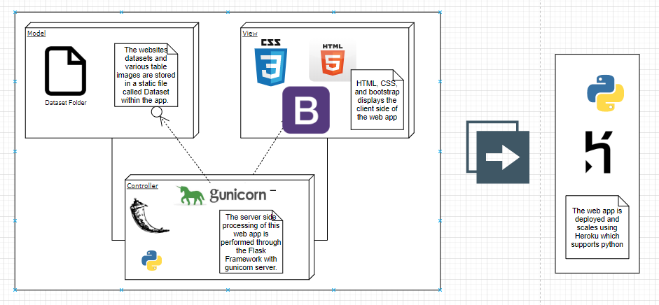

Anvil web app

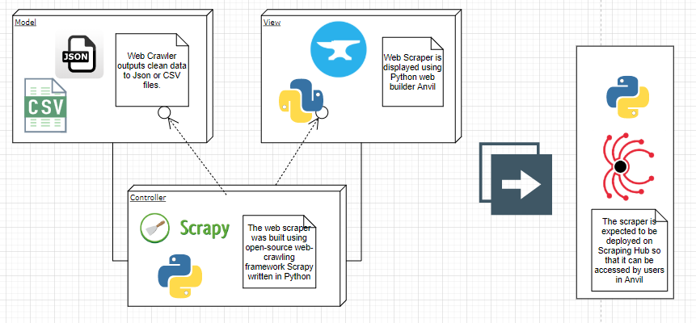

## System and Subsystem Decomposition

Our system can be broken down into four separate subsystems: User Interface, User Input, File Storage, and Visualization.

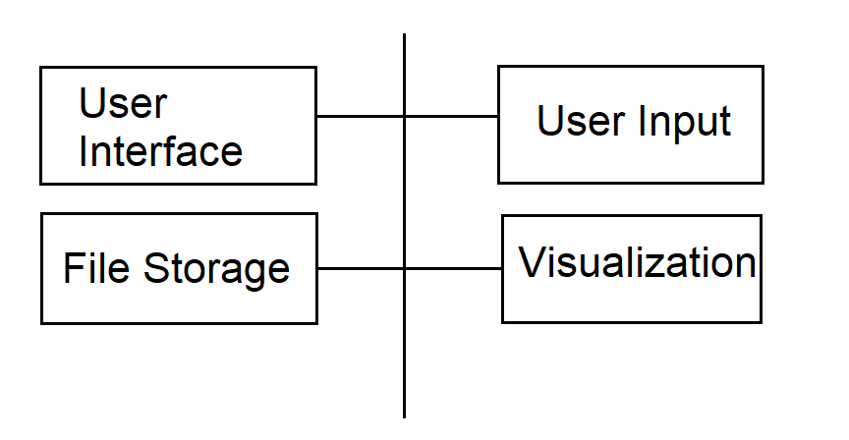

**User Interface**

The interface is responsible for providing the means for a user to experience the product either by following the lesson or by inputting a search term for the scraper on the Anvil web app.

**User Input**

User input is responsible for accepting a search term from the user in the Anvil app and processing the request by calling the scraper

**File Storage**

File storage is responsible for keeping our datasets and feeding the data to flask when it is called.

**Visualization**

Visualization is responsible for Displaying the results of the scraped data on the Anvil web app once it has been returned from the web scraper.

## Deployment Diagram

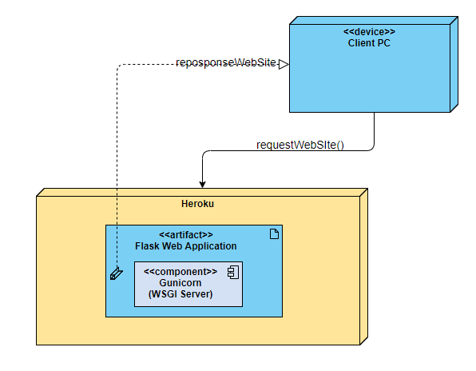

# System Validation

This section will offer a variety of test cases for the web scraper. Since the website has no user input, system validation has been achieved through rigorous elimination of bugs throughout development. We will begin by showing various test cases for our web scraper.

To begin, we navigate to the “web scraper” folder of the project directory and use *scrapy crawl testfile* to run the scraper. As you see below, the program will ask the user to input a search term for amazon:

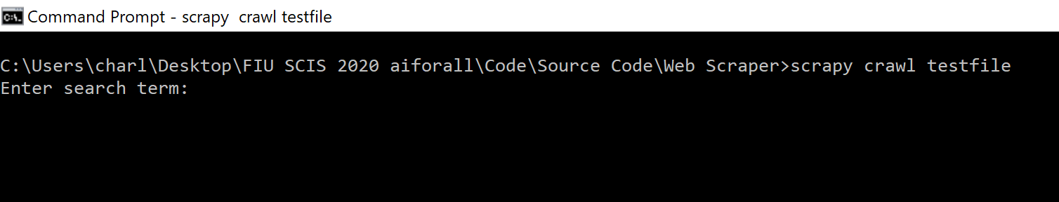

The program is designed to accept any search input that amazon itself accepts. However, since we only want queries for products (shoes, watches, pants, toys, etc.), the scraper is designed to return empty for queries that don’t take this point into consideration. Imagine you are surfing the amazon homepage. To find a specific product, you would enter a search query using the main search bar at the top of the page:

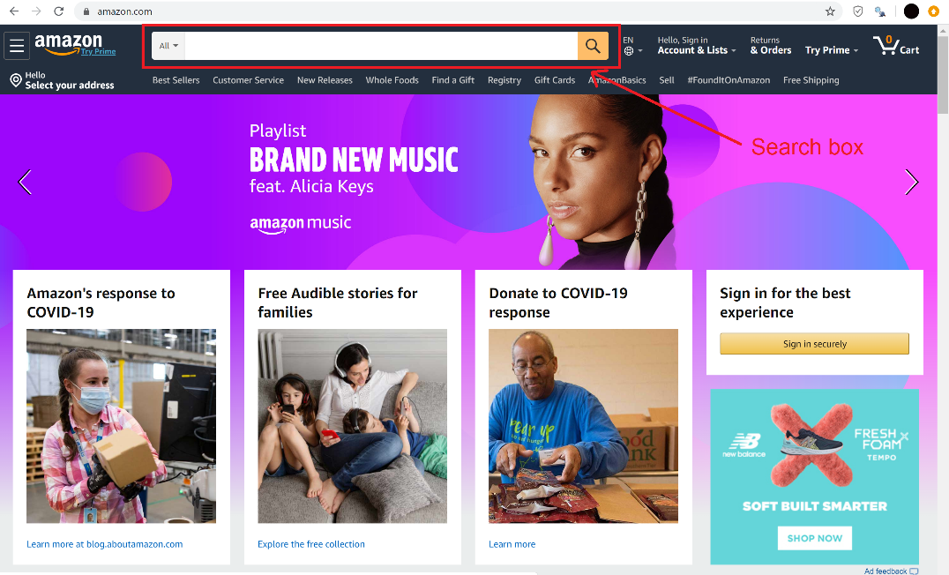

Let’s input a couple of queries and see what happens. We start with something simple: “shoes”

(notice red arrow pointing to current input query)

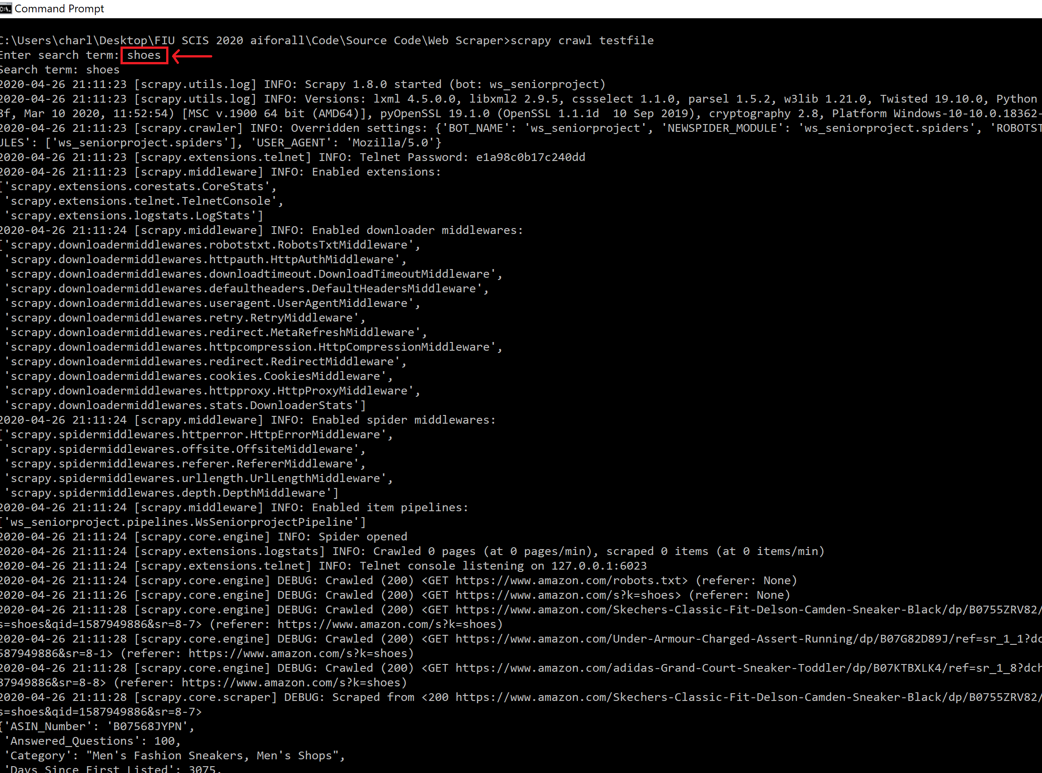

The scraper ran fine and has returned 9 items. This number has been set as the default number of returns but can be changed very easily (see user manual). Take a look at the first of these 9 items, which in this initial example we have highlighted for you:

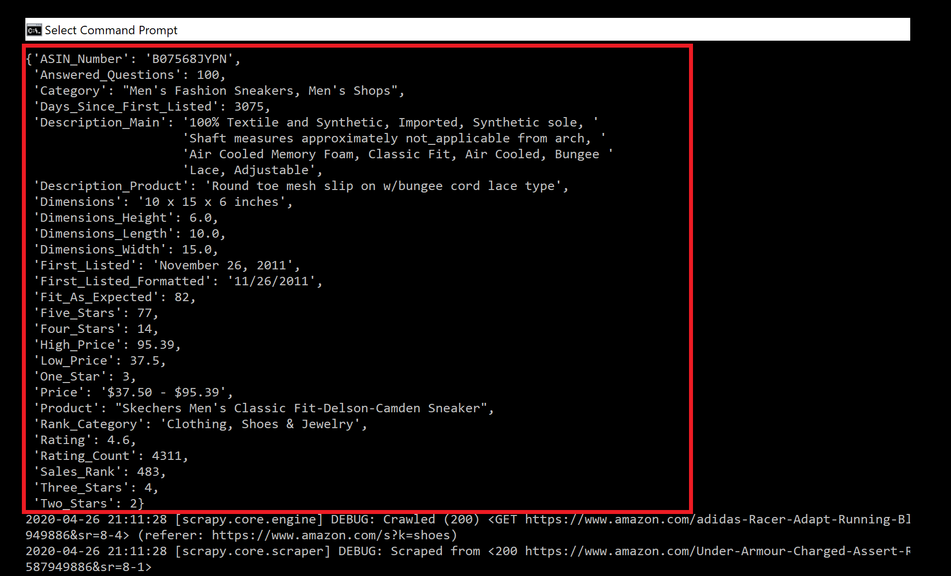

The remaining items have identical structure and only differ in the value of their elements. Take item #2 as an example and use it to contrast the first item:

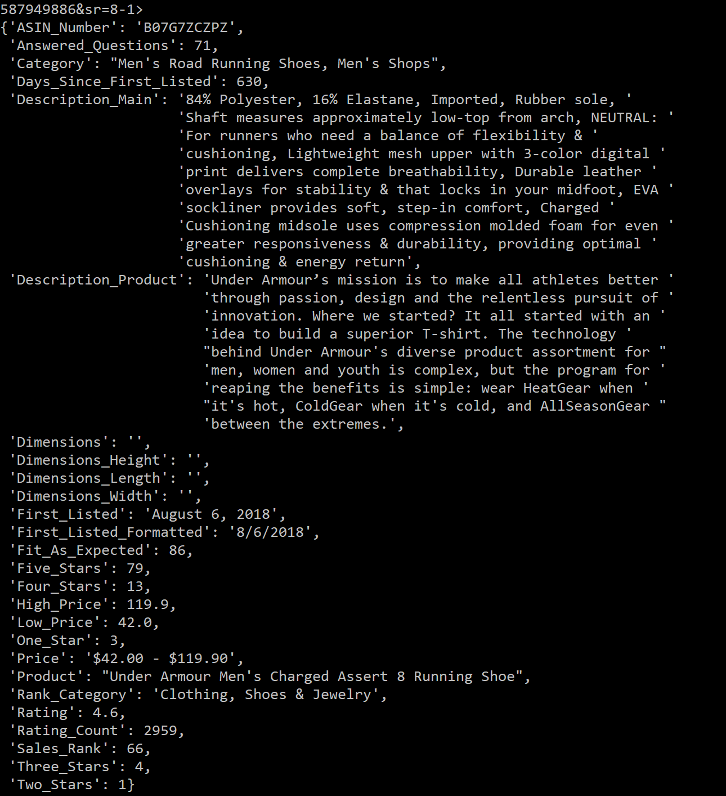

We now input another item: “watches”

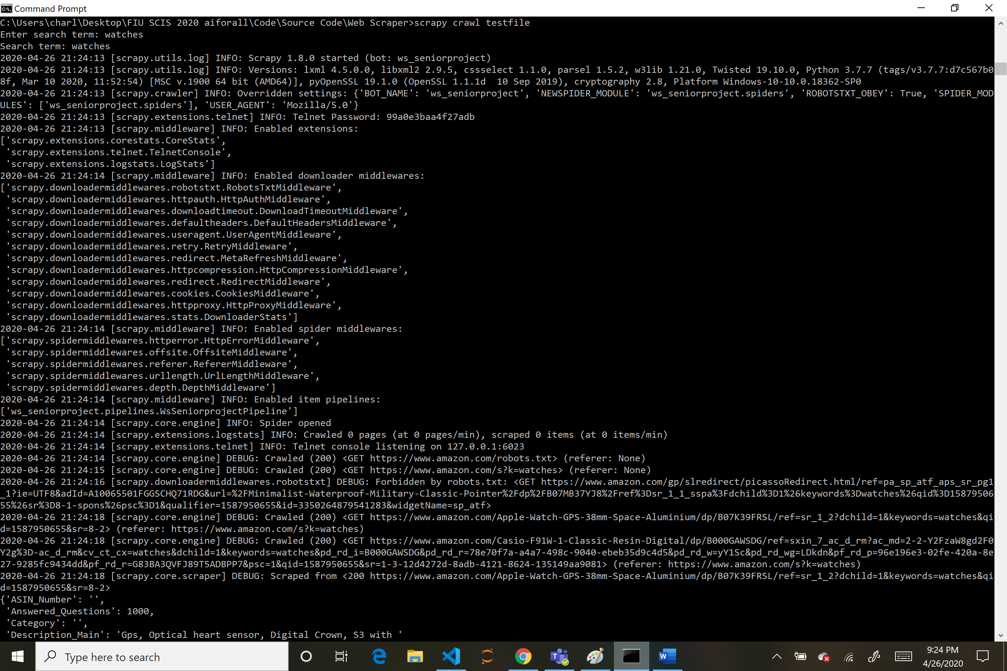

Notice how the web scraper ran fine and the appropriate results were returned. However, amazon’s robots.txt file forbid our scraper from accessing one of the products. This tends to happen occasionally and doesn’t harm our other results or stop the scraper. We simply receive 8 items instead of 9.

The web scraper is also designed to accept queries that are multiple words. For example, let’s return to our first query “shoes”. If we wanted to receive shoes of a certain brand such as “nike”, we would search for “nike shoes”. Our web scraper has no problem accepting this request:

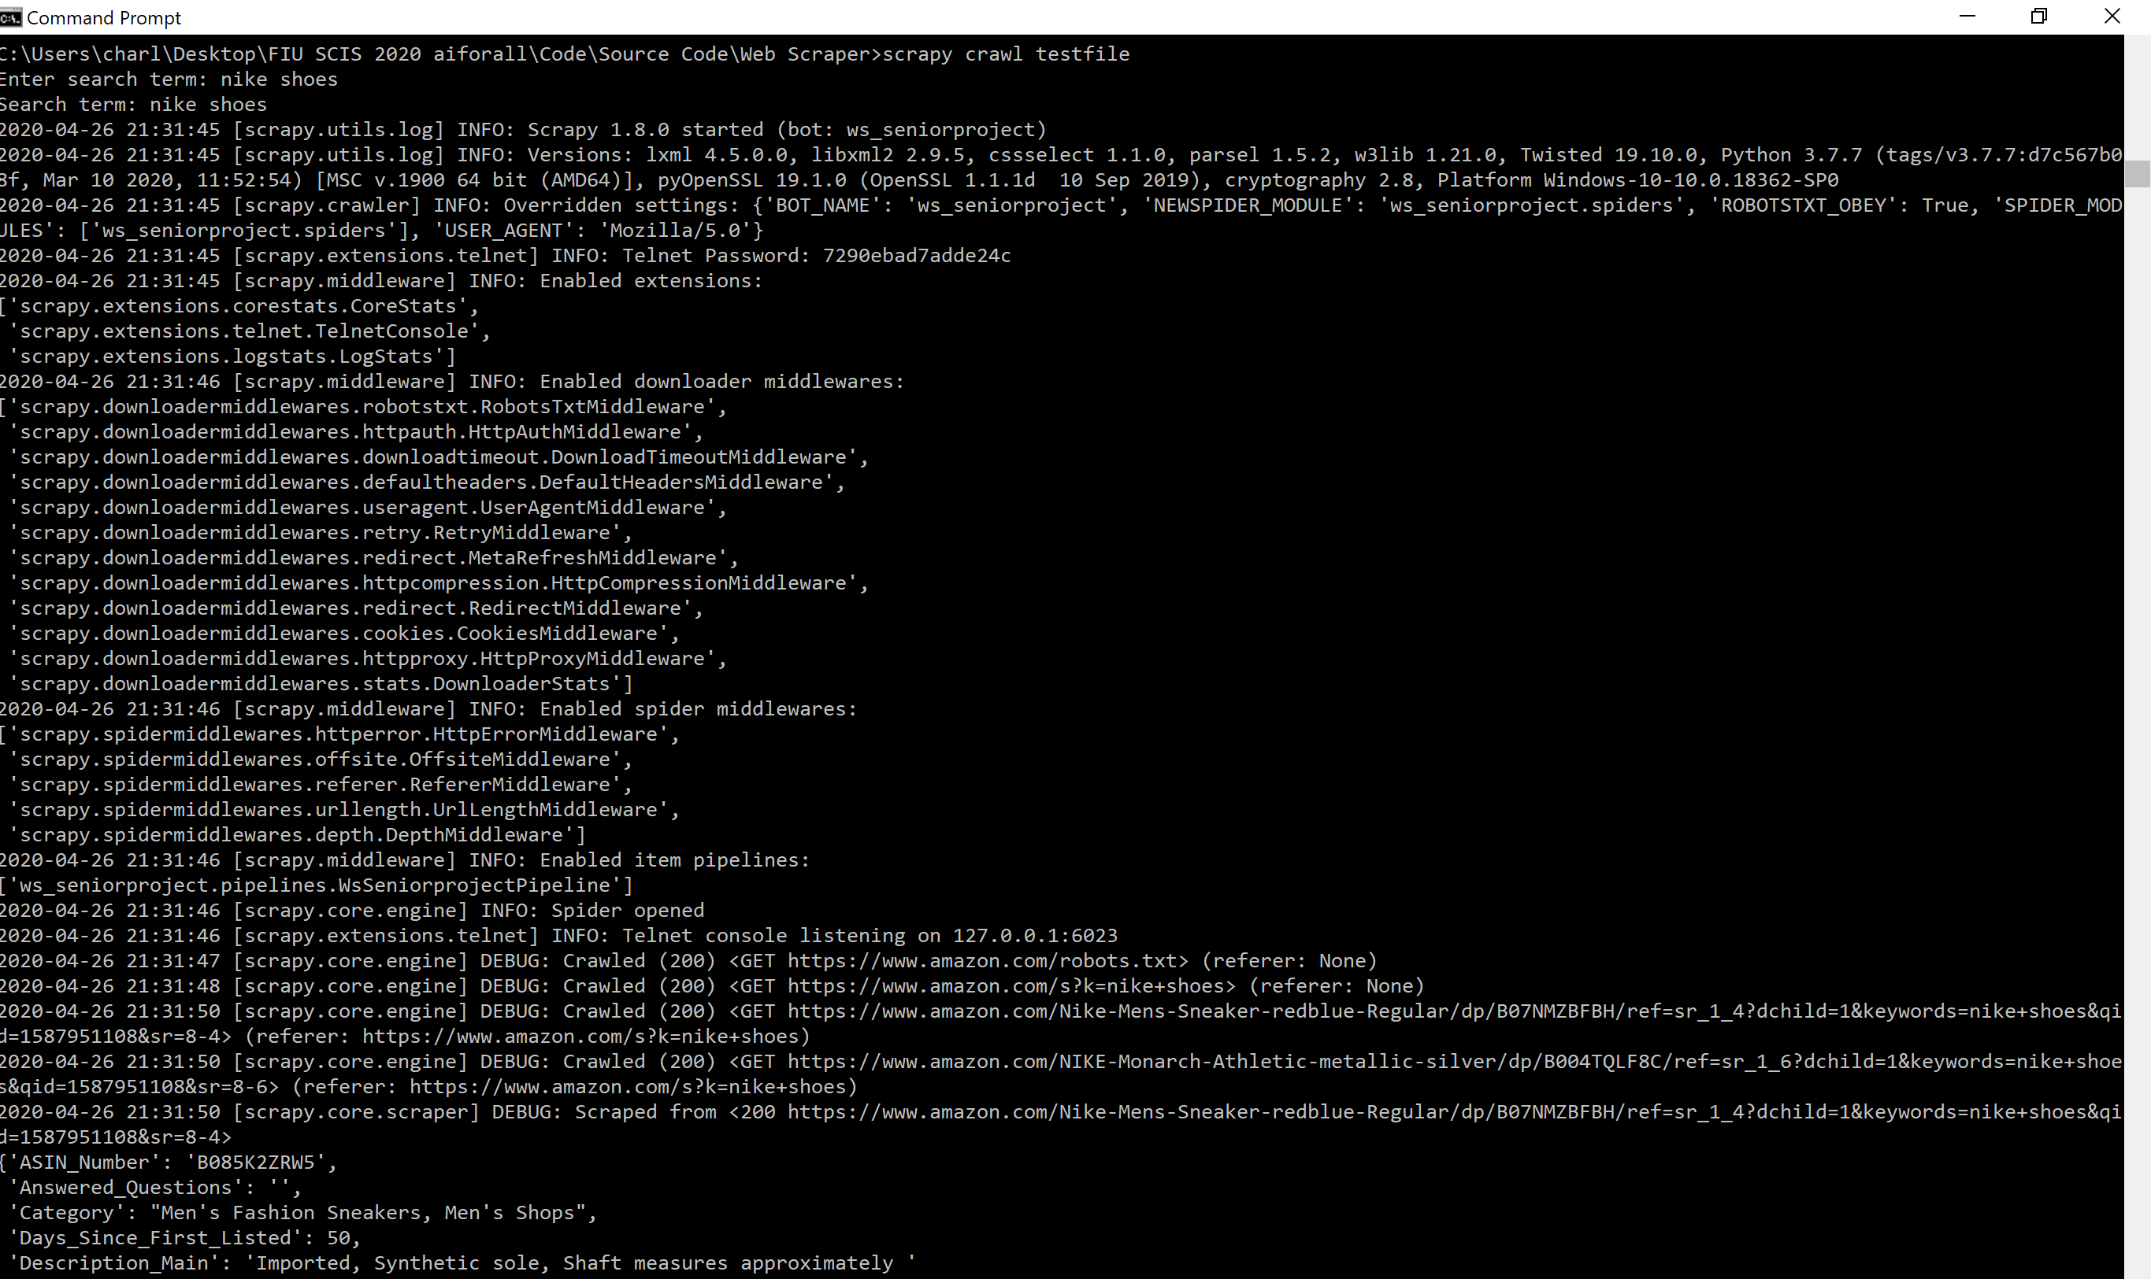

Anvil Validation

The anvil app is validated by first testing if the scraped data can be uploaded into it. We open the ‘Web Scraper’ Tab in the web app and type in a product that we would like to scrape. This function is validated if the data appears in a table 3 seconds later.

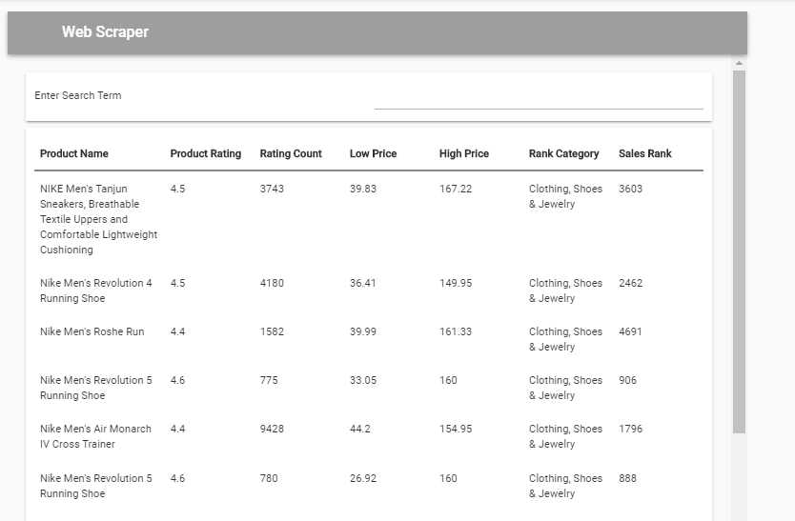

The data appears when anvil is connected to the local server which means that this function passed.

Anvil should be able to create diagrams based on this data.

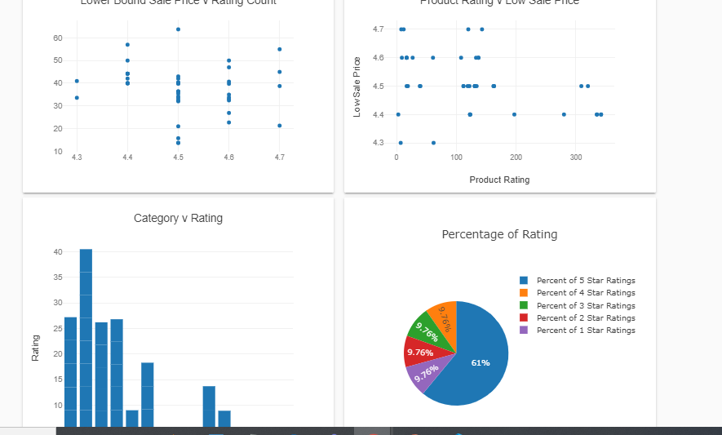

The app demonstrates that Anvil uses the current data to create visualizations meaning that this part is validated.

# 

# 

# 

# Glossary

In this section, we will be providing the definition of commonly used words throughout our project.

**Artificial Intelligence -** A non-human program or model that can solve sophisticated tasks. For example, a program or model that translates text or a program or model that identifies diseases from radiologic images both exhibit artificial intelligence.

**Clustering -** Grouping related examples, particularly during unsupervised learning. Once all the examples are grouped, a human can optionally supply meaning to each cluster.

**Dataset –** A collection of examples.

**Deep Learning -** A subset of machine learning in artificial intelligence (AI) that has networks capable of learning unsupervised from data that is unstructured or unlabeled. Also known as deep neural learning or deep neural network.

**Example -** One row of a dataset. An example contains one or more features and possibly a label. See also labeled example and unlabeled example.

**Indexing -** The process by which search engines organize information before a search to enable super-fast responses to queries.

**Linear Regression -** Using the raw output (y’) of a linear model as the actual prediction in a regression model. The goal of a regression problem is to make a real-valued prediction. For example, if the raw output (y’) of a linear model is 8.37, then the prediction is 8.37.

**Logistic Regression** - A classification model that uses a sigmoid function to convert a linear model's raw prediction (y’) into a value between 0 and 1.

**Machine Learning -** A method of data analysis that automates analytical model building. It is a branch of artificial intelligence based on the idea that systems can learn from data, identify patterns and make decisions with minimal human intervention.

**Matplotlib** - An open-source Python 2D plotting library. matplotlib helps you visualize different aspects of machine learning.

**Numpy -** An open-source math library that provides efficient array operations in Python. pandas is built on NumPy.

**Outliers -** Values distant from most other values. In machine learning, any of the following are outliers:

* Weights with high absolute values.
* Predicted values relatively far away from the actual values.
* Input data whose values are more than roughly 3 standard deviations from the mean.

Outliers often cause problems in model training.

**Pandas** - A column-oriented data analysis API. Many machine learning frameworks, including TensorFlow, support pandas data structures as input. See the pandas documentation for details.

**Web crawler-** Sometimes called a spider or spiderbot and often shortened to crawler, is an Internet bot that systematically browses the World Wide Web, typically for the purpose of Web indexing

**Web scraping***-*  The extraction of data from a website. This information is collected and then exported into a format that is more useful for the user

# Appendix

## Appendix A - UML Diagrams

*Sequence diagram for our Anvil web app*

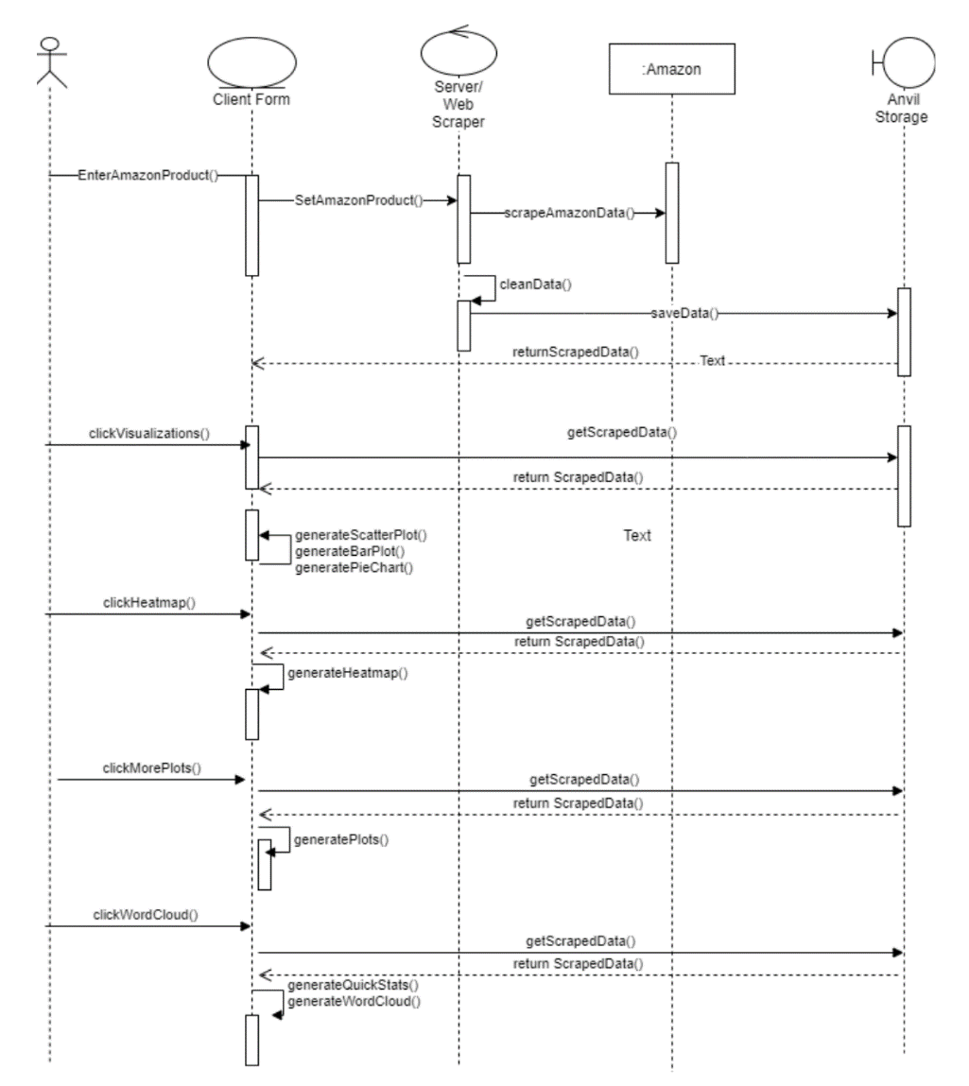

*Sequence diagram for our Flask Web App (our website)*

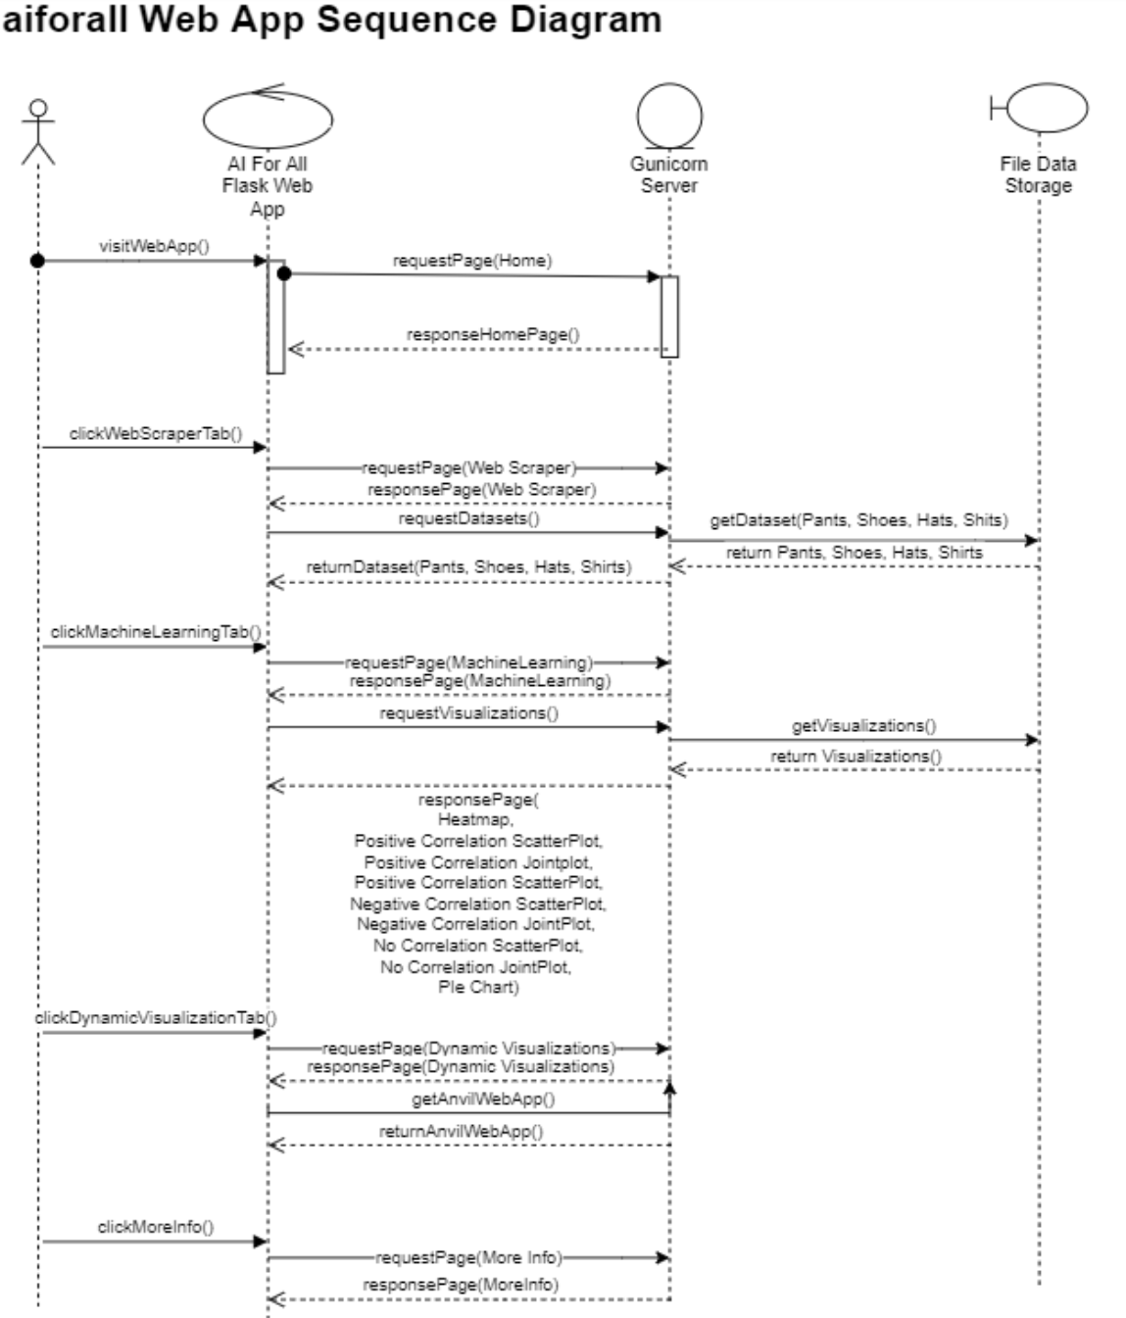

*Class diagram*

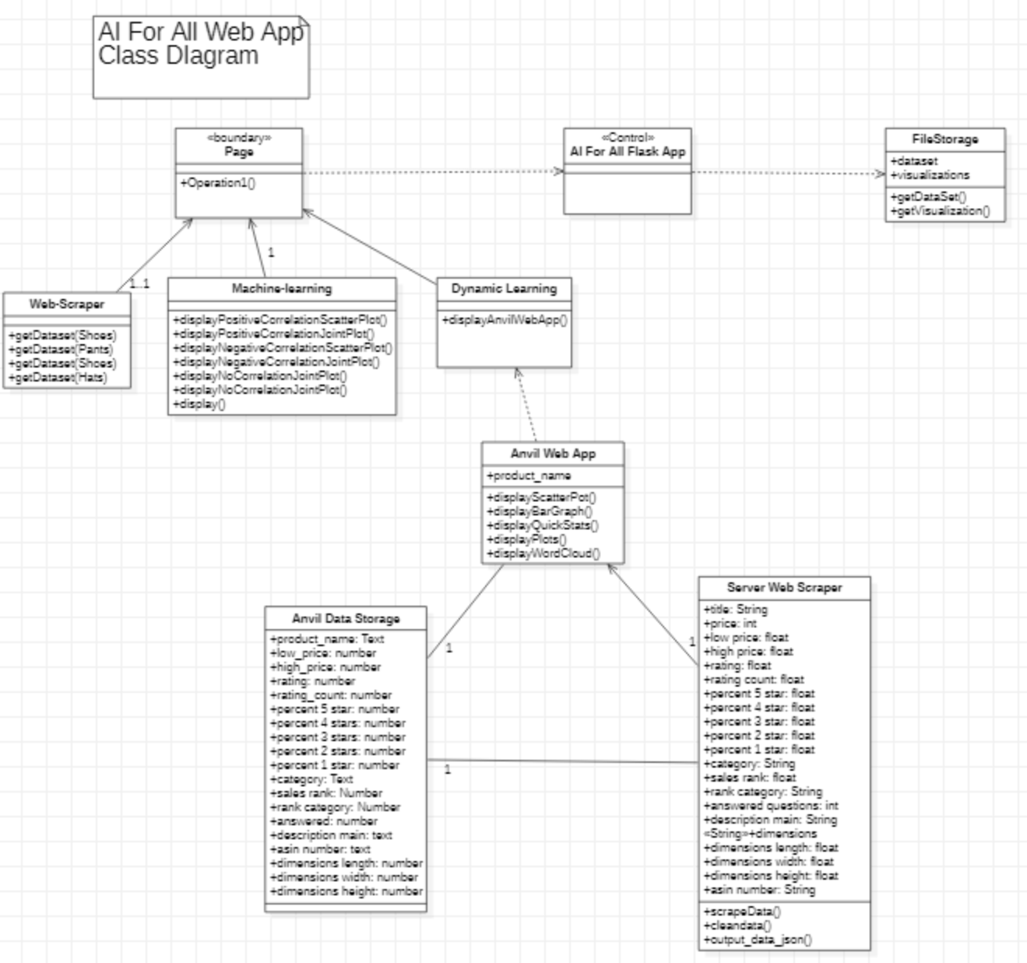

*Use Case diagram*

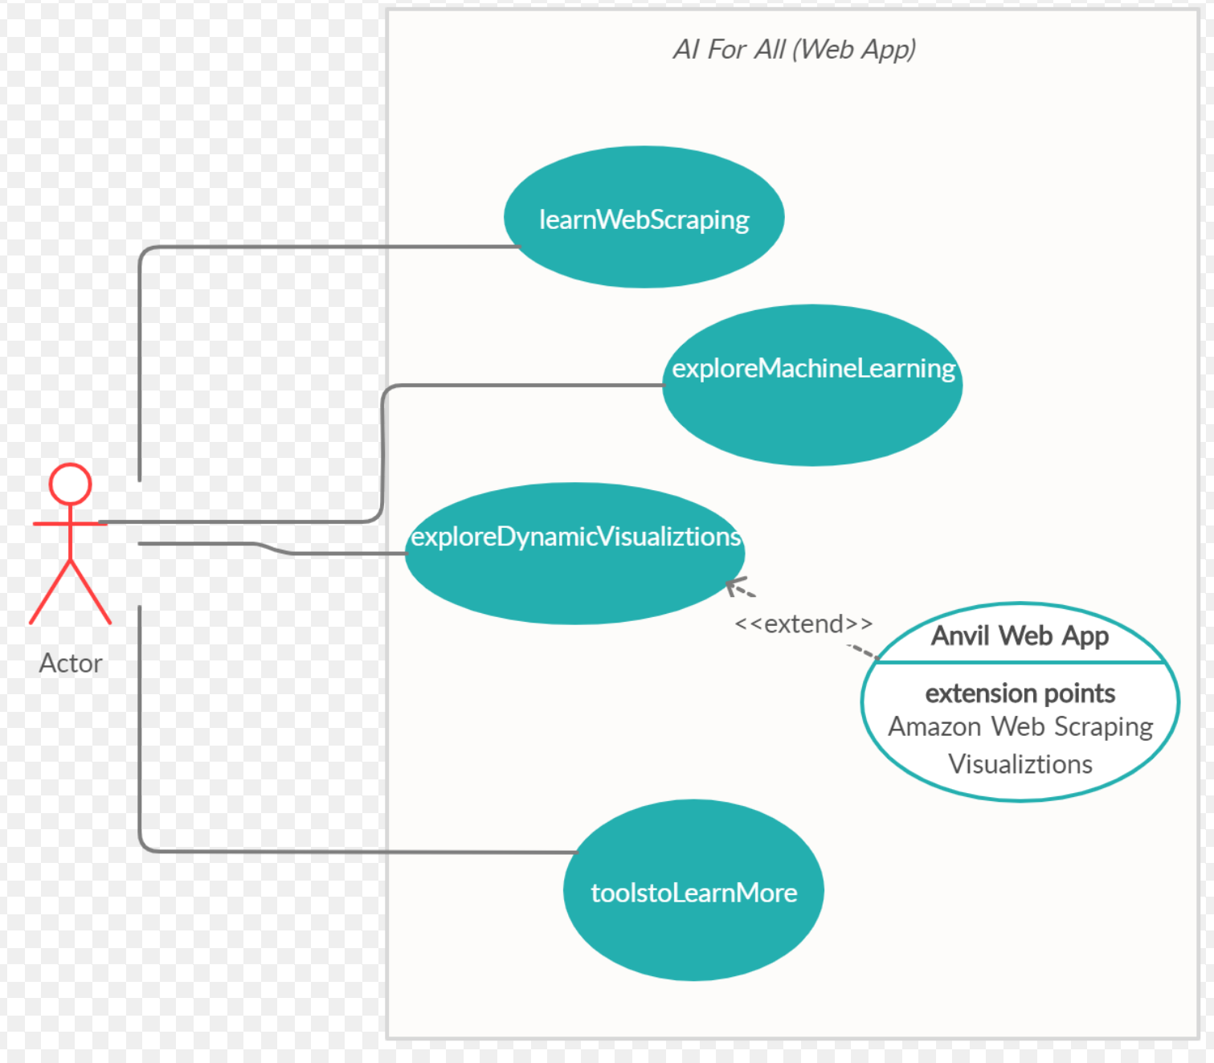

## 

## Appendix B - User Interface Design

Our project is composed of 3 parts: a web scraper, a website, and an anvil web app. The web scraper can serve as a standalone tool as shown in the “web scraper” folder in the “code” directory. However, the main intention of the web scraper is to be an integral part of the web app. For this reason, this section will only show user interface design for the website and for the web app. A standalone web scraper user interface is shown in the user guide file of the “web scraper” folder in the “code” directory.

**Website**

The website can we reached using the address www.itsaiforall.com (alternatively: <https://aiforall.herokuapp.com/>)

The first thing a user will see is the home page (screenshot shown below)

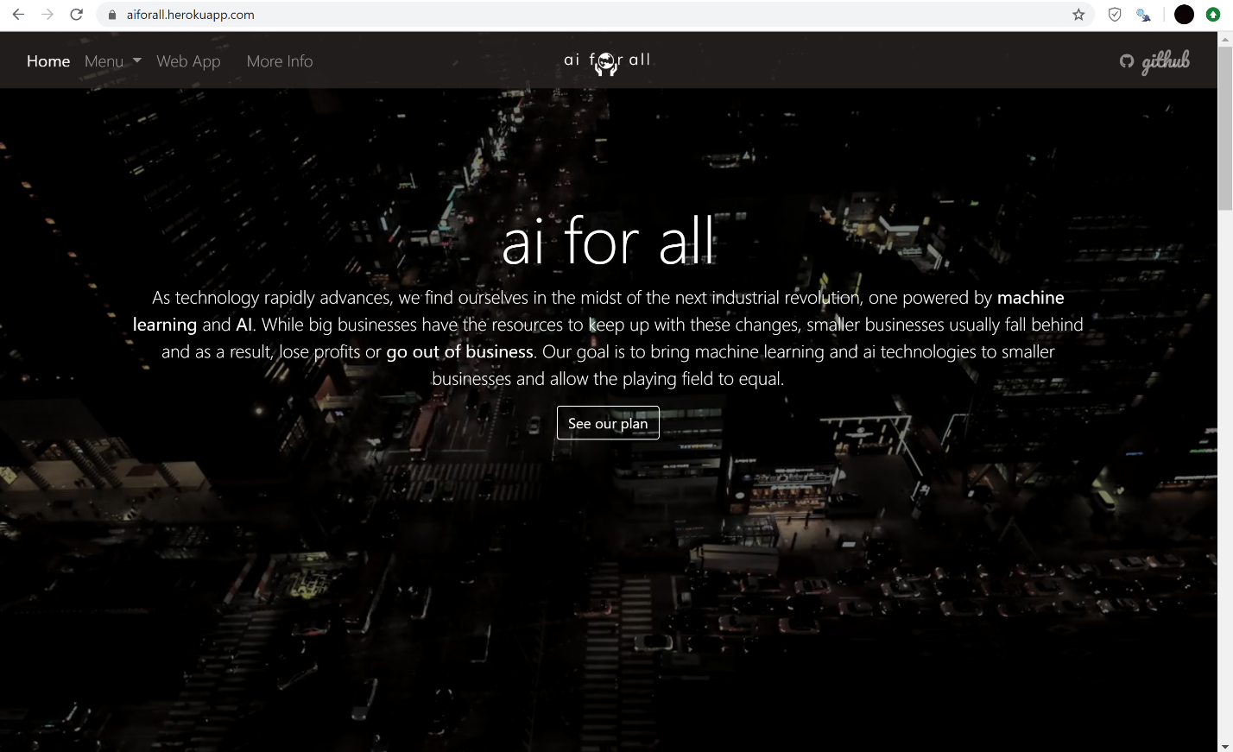

The main page of the website tells us the purpose of our project *ai for all* and its components. Scrolling down shows this section. (screenshot down below)

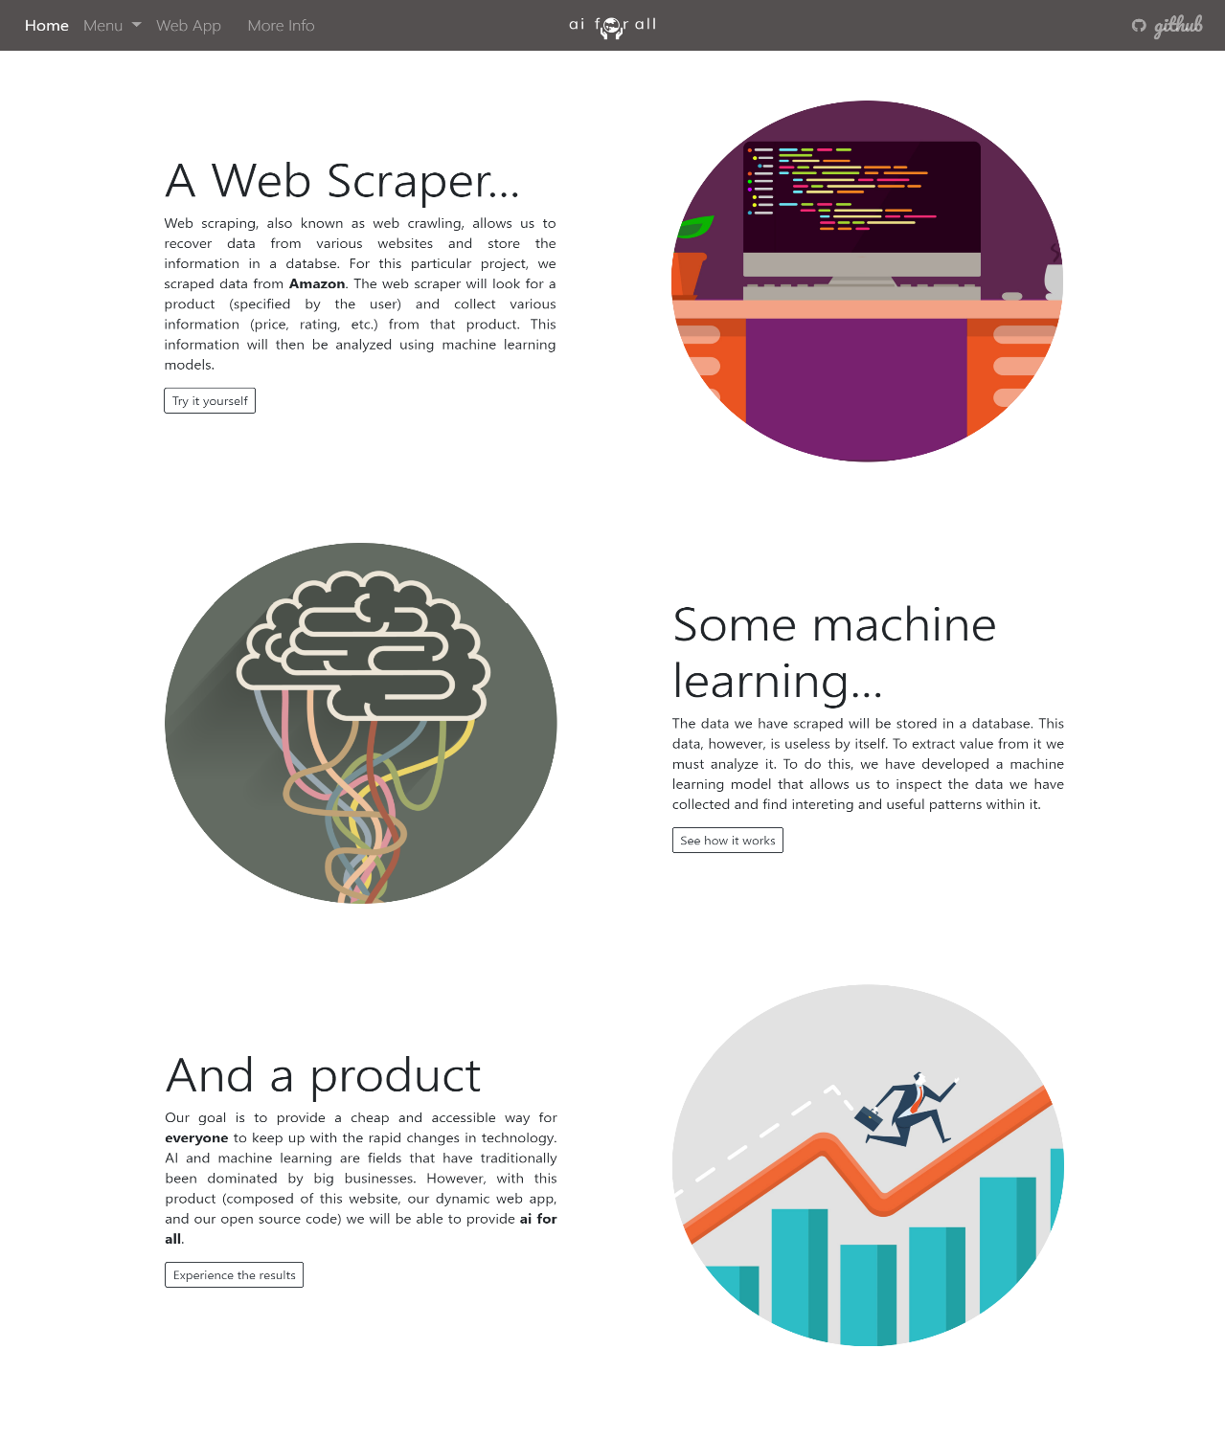

Our website has three main pages: A “web scraper” page showing the process of creating a web scraper including how it works and its multiple components, a “machine learning” page showing the data cleaning process and how machine learning works, and a “dynamic visualizations” page presenting our web app and its functionality. These three main pages will most likely turn into four main pages in subsequent versions of the website (splitting up data cleaning and machine learning into two separate pages), meant to be developed and released after the April 27 deadline. Additionally, our website has a “more info” page which serves as a guide for expanding your knowledge on key topics such as deep learning.

The navigation bar of the website shows us all these pages and allows us to navigate to them.

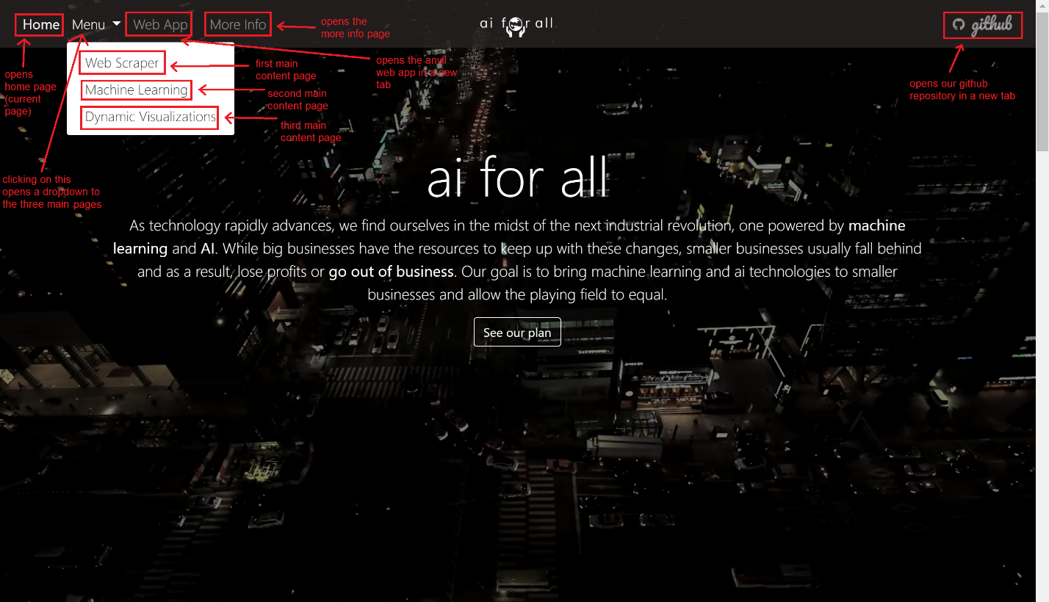

The first page is the “web scraper” page. Below is a screenshot of the first thing you see once you navigate to this page.

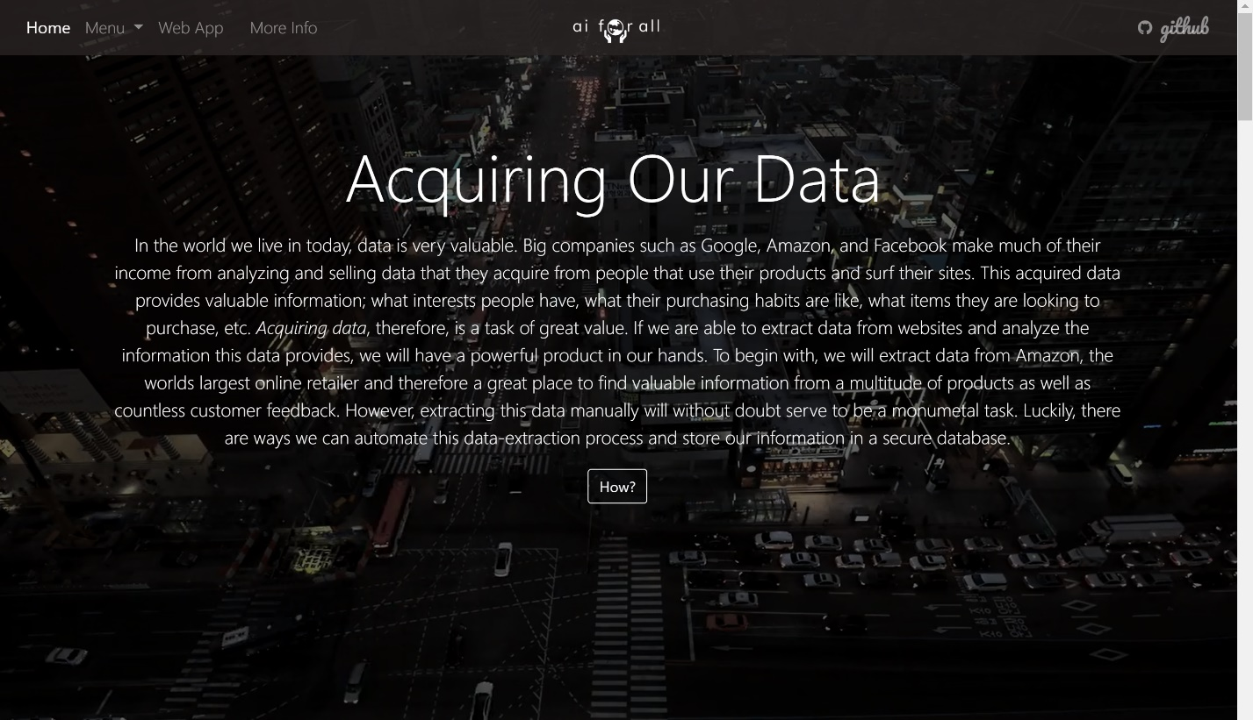

The contents of this page show us how a web scraper works and shows examples of results from our own custom web scraper. Below is a dropdown of different datasets the user has the option of selecting.

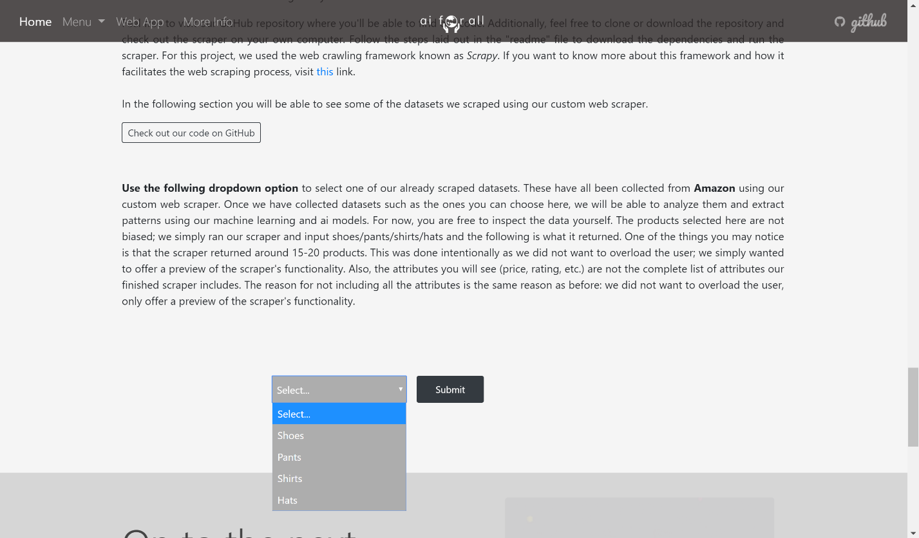

Choosing one of the options opens the results of the web scraping. (shown below)

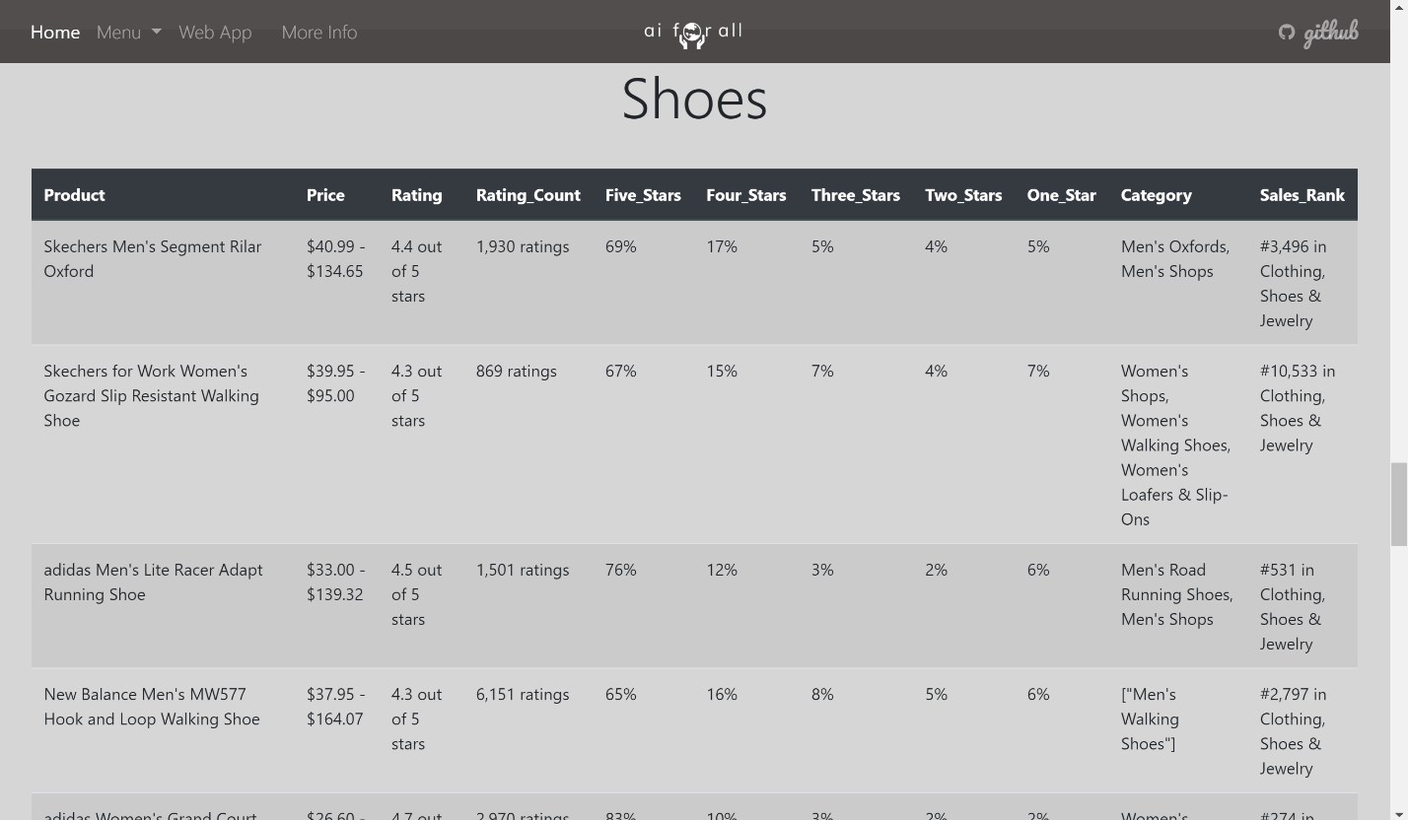

The next page is our “machine learning” page. The first thing you see when you open this page is shown in the following screenshot.

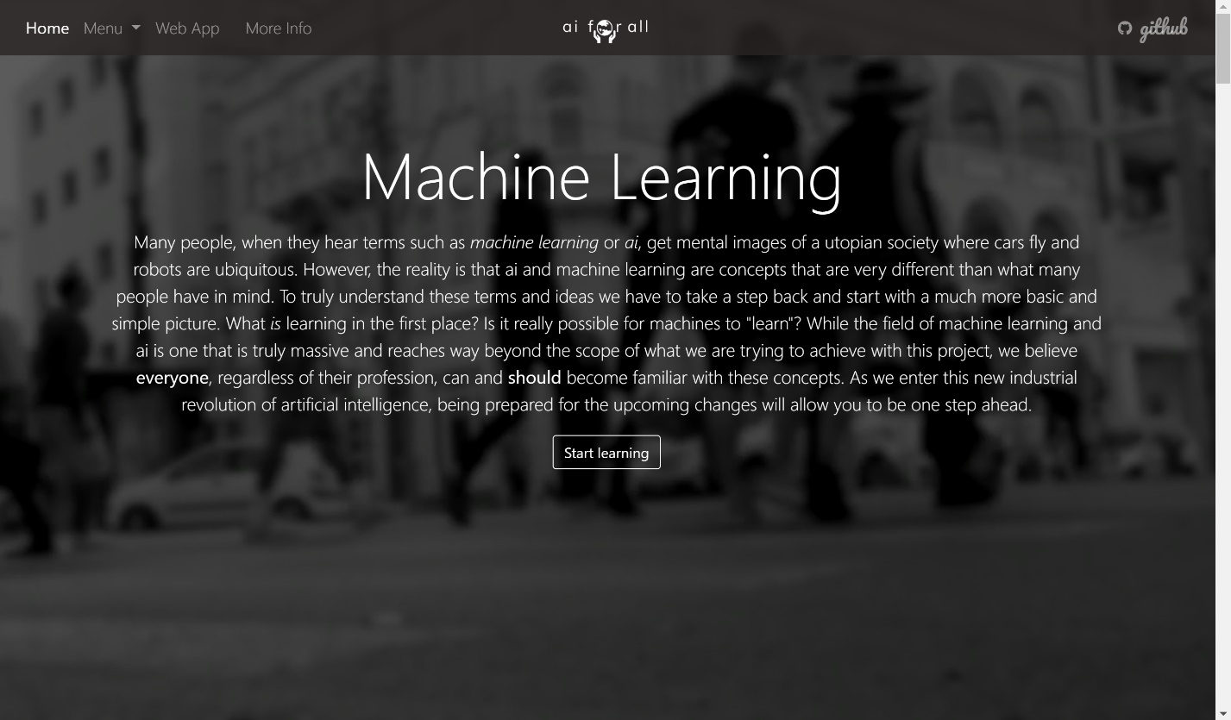

The contents of this page are divided into two parts: how data is cleaned and how machine learning works. There is a dropdown in the machine learning section that allows users to select a data visualization model. The following screenshot shows this dropdown menu.

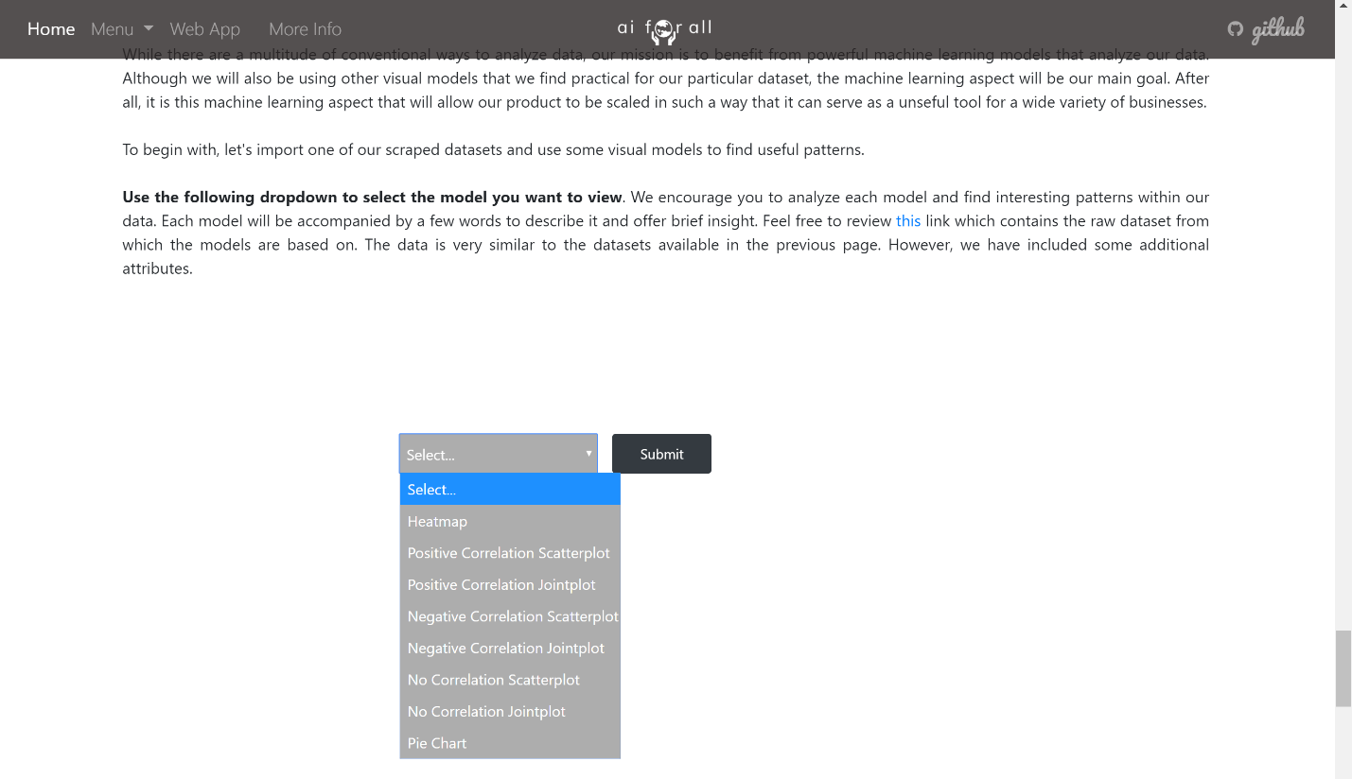

Selecting an option opens the visualization and a short explanation of the model.

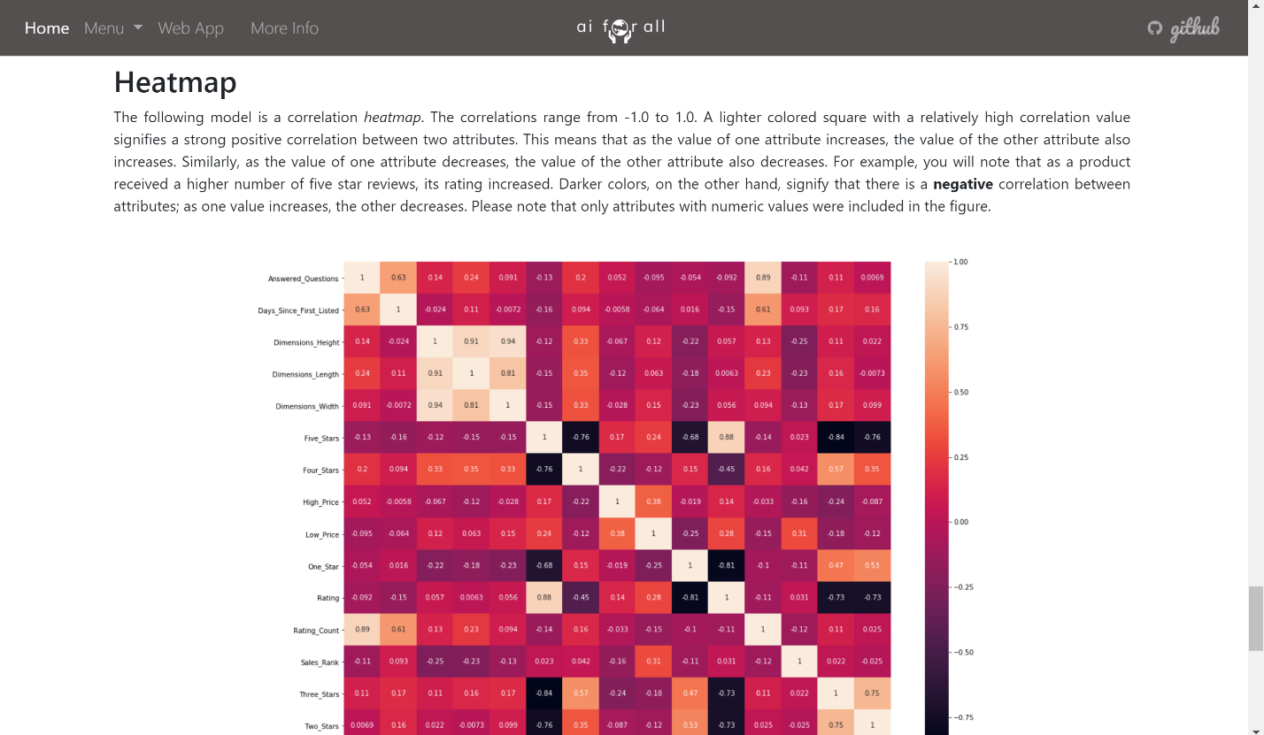

The third main content page is the dynamic visualizations page that includes the introduction to our web app. The following is a screenshot of the first thing a user sees once it’s opened.

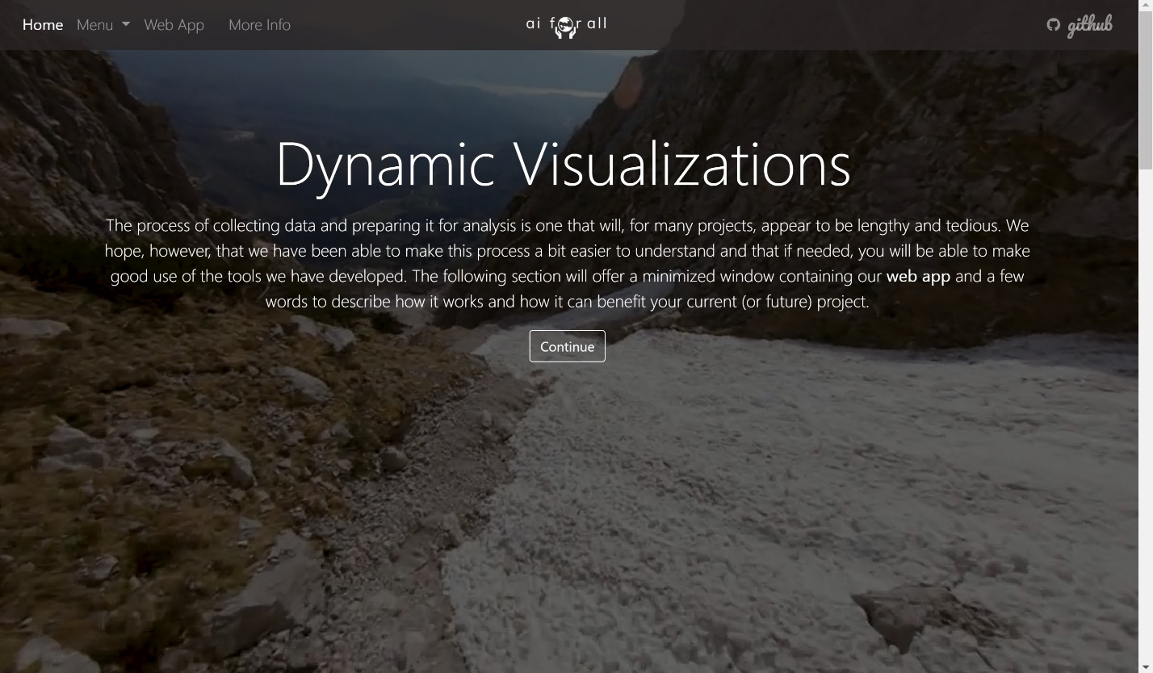

The page also includes a frame which allows a user to navigate the web app without having to leave the webpage. However, easier navigation is achieved if a user opens the web app in a new tab by clicking on the link in the navigation header.

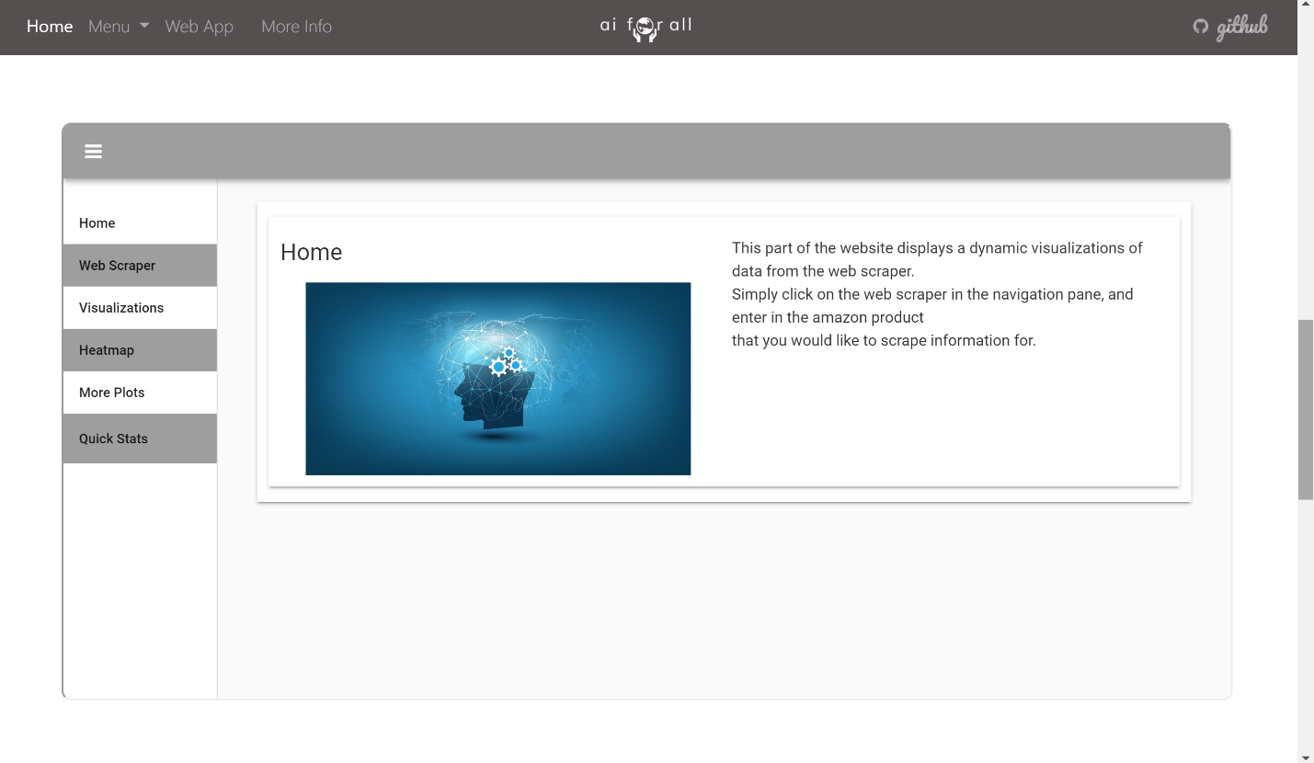

The “more info” page is brief yet very powerful in the sense that a multitude of quality resources are linked. When a user clicks on the link in the navigation bar of the website, it opens a page that looks like this:

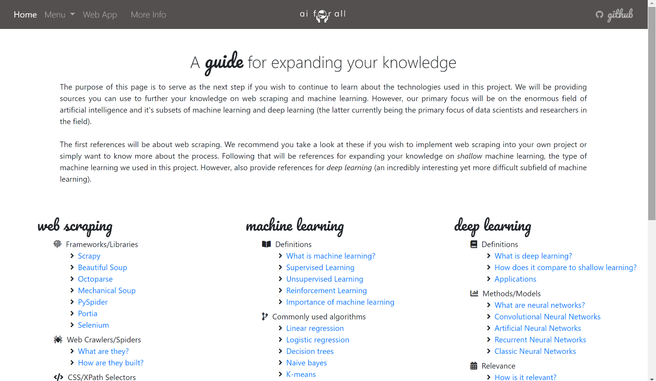

The contents of the website footer are all the same and look like this:

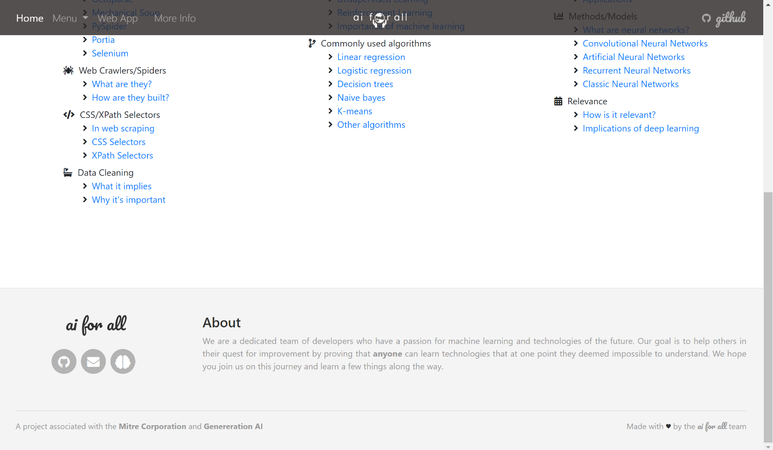

The footer includes an “about” section that briefly states our goal for this project. On the left-hand side, it includes links to three pages: out GitHub repository (left), an “email us” link (middle), and a link to the “Generation AI Nexus” page.

## Appendix C - Sprint Review Reports

Sprint review reports have been placed together with each corresponding sprint in the “Sprints plan” section of this document.

## Appendix D - User Manuals, Installation/Maintenance Document, Shortcomings/Wishlist Document and other documents

**User Manual**

**Index**

1. Navigation Bar
2. Home Interface
   * 1. First words
     2. *An interesting idea* section

iii) Three main content components

1. Web Scraper Page
   * 1. First words
     2. *How we did it* section
     3. *The benefits of using a web scraper* section
     4. *How does it work?* section
2. Machine Learning Page
   * 1. First words
     2. *Where do we begin?* Section
     3. *What is machine learning?* Section
     4. *Visualizing data* section
3. Dynamic Visualizations Page

i) First words

ii) *A web app* section

iii) *What’s next?* Section

1. More Info Page
2. Footer

1. Navigation Bar

The navigation bar exists on every page of our website. It is a responsive navigation bar that is designed to be easy to use no matter the size of the device you are working on.

The navigation bar begins with a “home” button that leads the user to the home page once clicked.

The second item on the navigation bar is a menu dropdown that gives the user the option of pressing on one of the three main content pages.

The third item on the navigation bar is a link to our web app. Pressing this will open it in a new tab.

The fourth item on the navigation bar is a link to our “more info” page.

The *ai for all* logo exists in the center of the navigation bar and also serves as a link to the home page.

A link to our opensource GitHub repository is the final item on the navigation bar and will open in a new tab once clicked.

2. Home Interface

i) The first thing a user sees when they open the website is our home page. The first words they read will give a brief overview of the importance of the project.

ii) *An interesting idea* section briefly describes how the project can be of benefit to a wide variety of people of all ages and professions as well as merchandisers and consumers.

iii) The three main components of our website are our “web scraper” page, our “machine learning” page, and our “dynamic visualizations” page. Brief words are given on the home page for each section and a button is present that will direct users to each page.

3. Web Scraper Page

i) Navigating to the “web scraper” page presents the user with a brief overview of why data acquisition is so valuable.

ii) The *how we did it* section describes *how* we can safely and quickly extract data from online webpages.

iii) The *benefits of using a web scraper* section shows users why they should use a web scraper and offers various resources they can use to expand their knowledge on useful file formats such as json and csv.

iv) The *how does it work?* section responds this very question regarding how a web scraper works. It presents the user with a variety of resources they can use to expand their knowledge on topics such as html, classes, ids, website structure, and indexing. Users are shown the two main components that went into the building of our web scraper and are encouraged to visit our opensource GitHub repository where they can clone the web scraper and make changes of their own.

The section also offers users the option of a dropdown menu that shows them how some of our scraped datasets look like.

4. Machine Learning Page

i) The first thing a user sees when they open the machine learning page is a brief overview of the importance of understanding concepts such as machine learning.

ii) The *Where do we begin?* section lets users know that we are not yet ready to feed our data to any models. The first thing we must do is make sure our data is *clean.* The section goes on to explain what it means for data to be clean and how we were able to clean our data after extracting it using our web scraper.

This section also gives users a variety of resources they can use to expand their knowledge on data types and functions.

iii) The *What is machine learning?* section gives users insight into this seemingly difficult to understand concept. The section is a beginner friendly introduction into machine learning and offers users resources they can use that can help them understand concepts such as *clustering* that are important in many machine learning algorithms.

iv) The *visualizing data* section allows users to see how, once the data is cleaned and ready to use, can be extremely useful. Visualization models give us different perspectives and allow us to witness the data in a variety of ways.

This section gives the user the option of a dropdown that includes a variety of data visualization models. Additionally, choosing an option will present users a brief paragraph that gives an overview of the model.

5. Dynamic Visualizations Page

i) The first thing a user is presented with once they open the dynamic visualizations page is a brief paragraph on the processes we have gone through to get to the current section. The data has been collected and cleaned and is now ready for further analysis.

ii) The *A web app* section has the purpose of introducing our anvil web app. After presenting the importance of dynamic content, the website loads a frame of the anvil web app that users can interact with.

iii) The *What’s next?* section serves as the concluding words of the website. Users are encouraged to visit our repository and benefit from the code we have created. Additionally, users are encouraged to visit our “more info” page where quality resources are offered to expand our knowledge.

6. More Info Page

The more info page serves as a guide for three main topics: web scraping, machine learning, and deep learning. The page is organized by way of three main subsections each corresponding to one of these topics. Link will open in new tabs with the purpose of keeping the website open in case additional links are to be visited.

7. Footer

The footer forms part of every page on our website and serves the purpose of giving users brief yet concise insight into the motivation of our team as well as various links. These links include: our GitHub repository, an *email us* link, and a link to the *Generation AI Nexus* homepage.

**Installation documents**

In this section we will be showing installation documents for multiple components of our project. Installing our project is not necessary to use it as our *ai for all* website (<https://aiforall.herokuapp.com/>) is already hosted on a heroku server. However, since our project has multiple components that can be used individually, we will be providing multiple installation guides. To begin with, we provide the installation guide for our website.

*Installing dependencies*

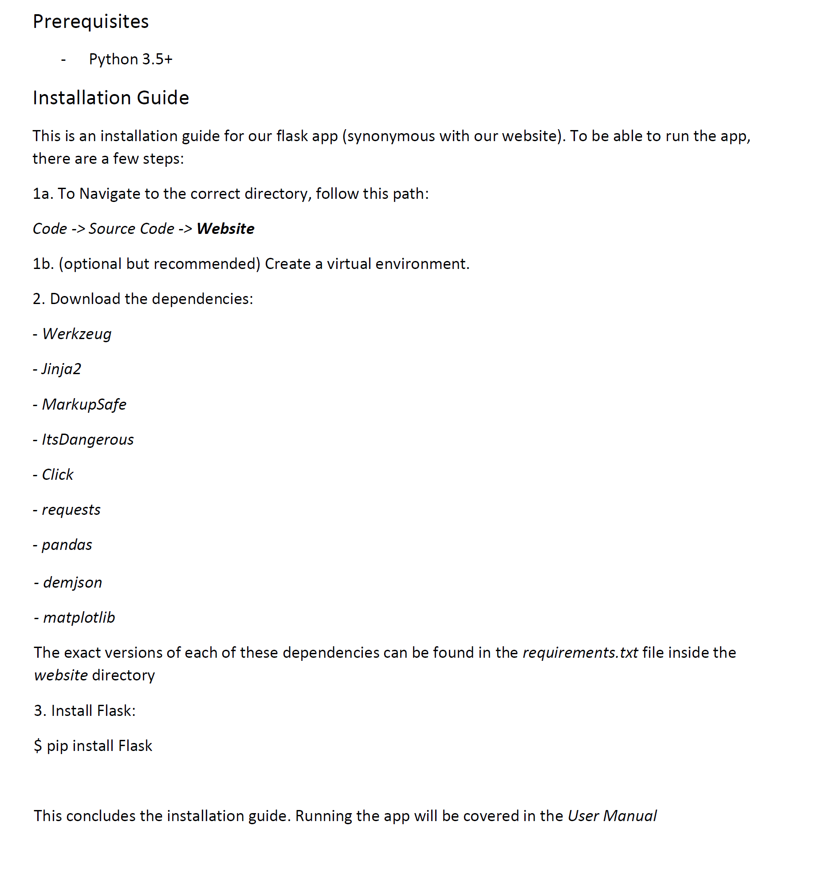

*Running on localhost*

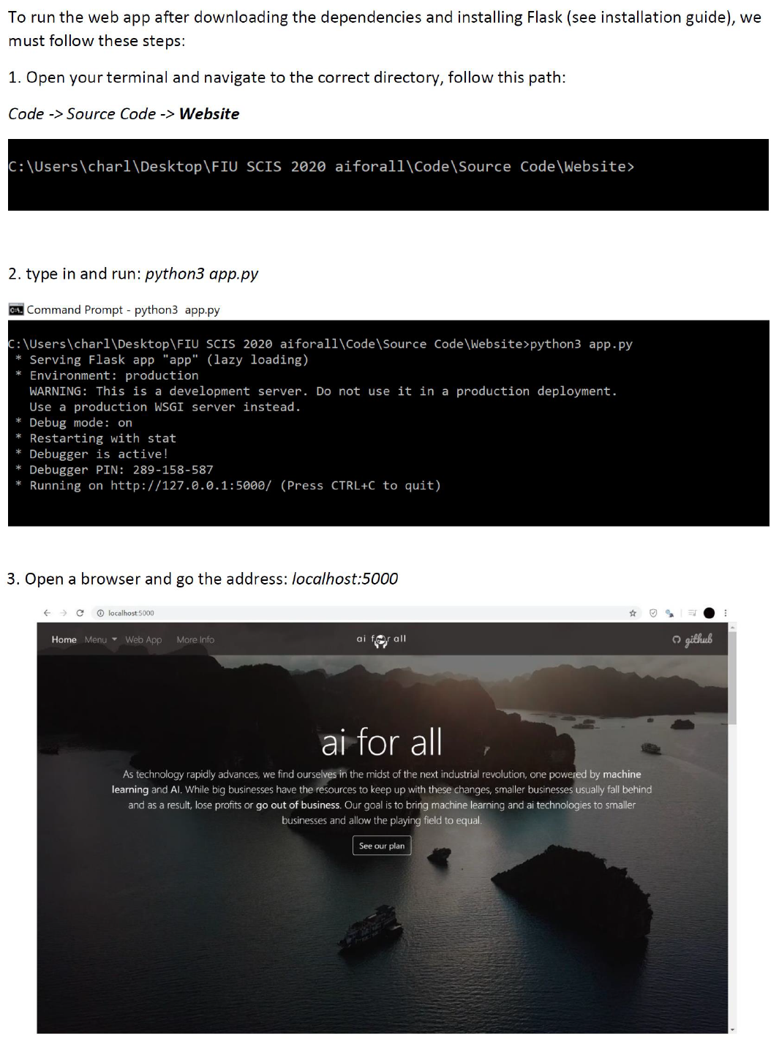

**Web Scraper Installation Guide**

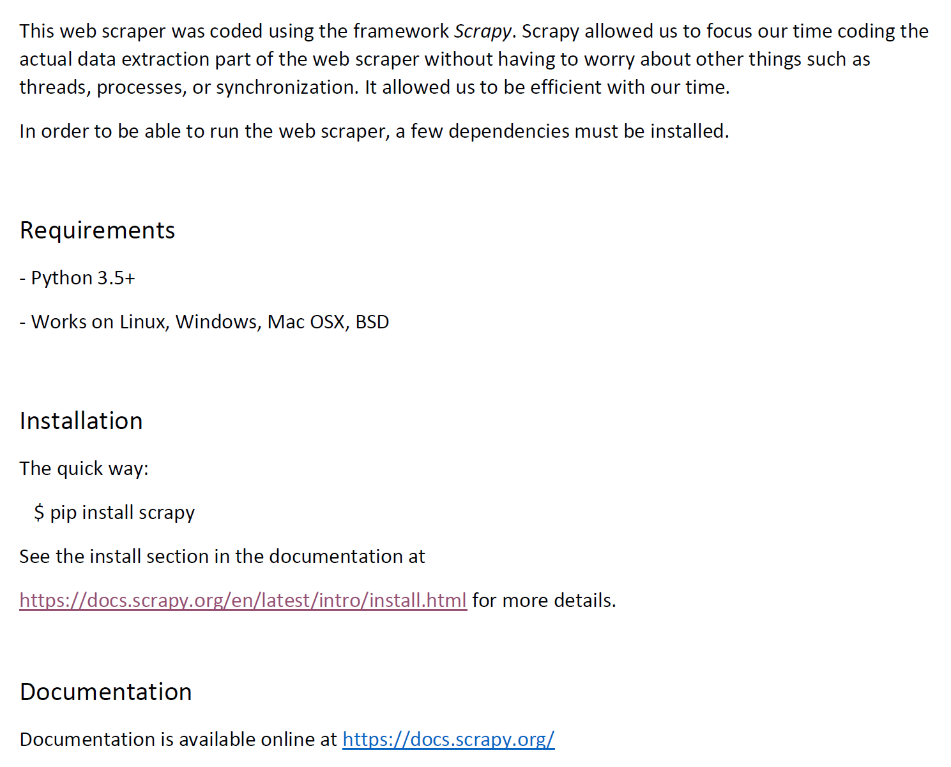

**How to run the scraper**

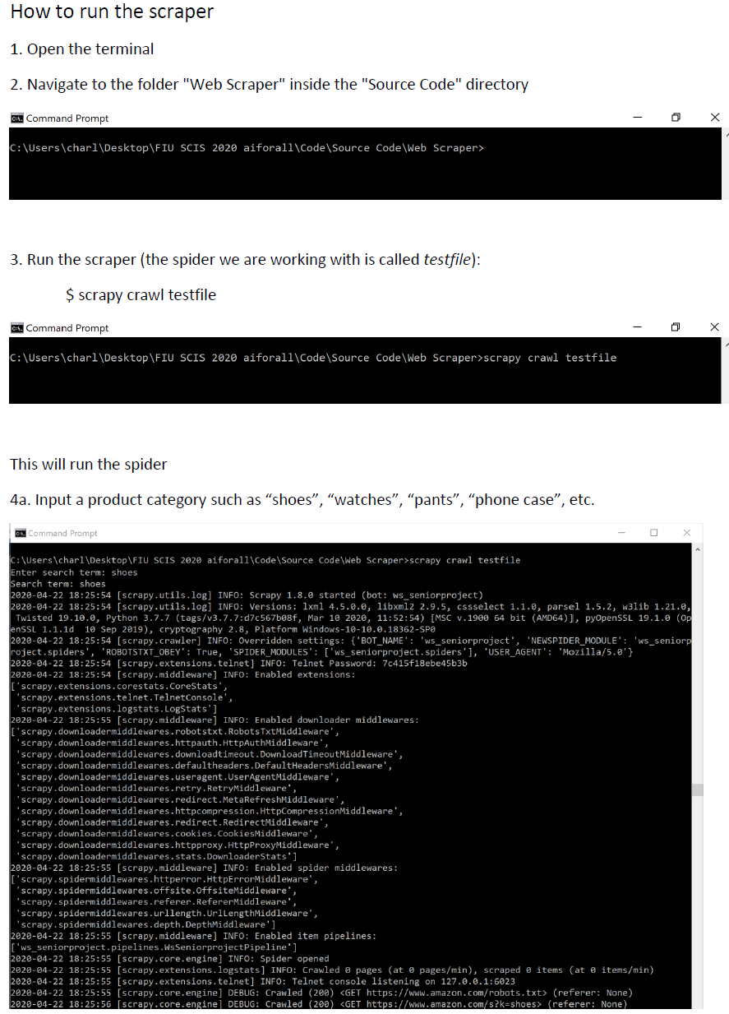

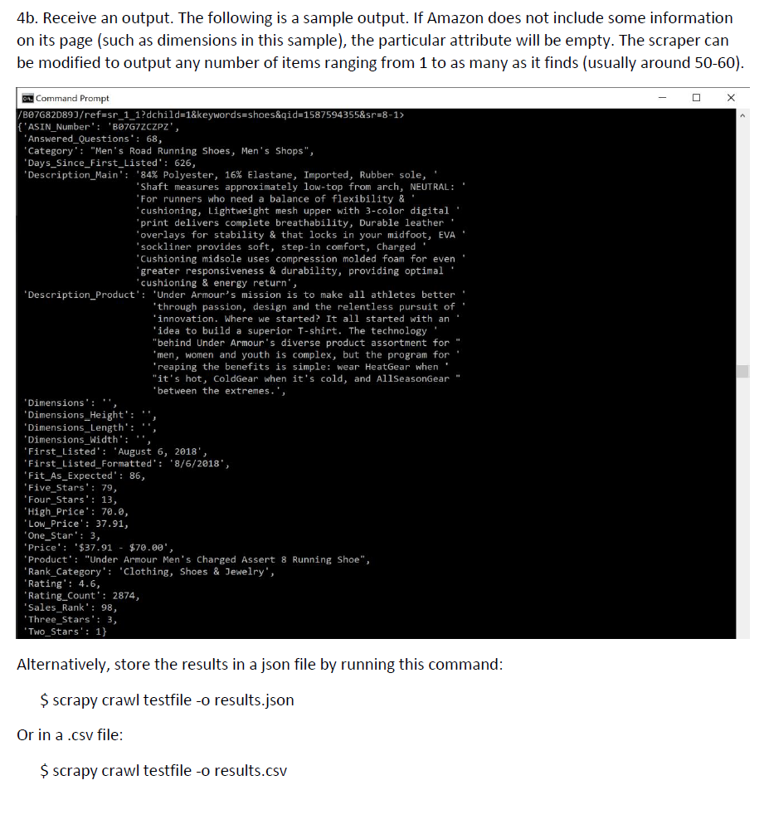

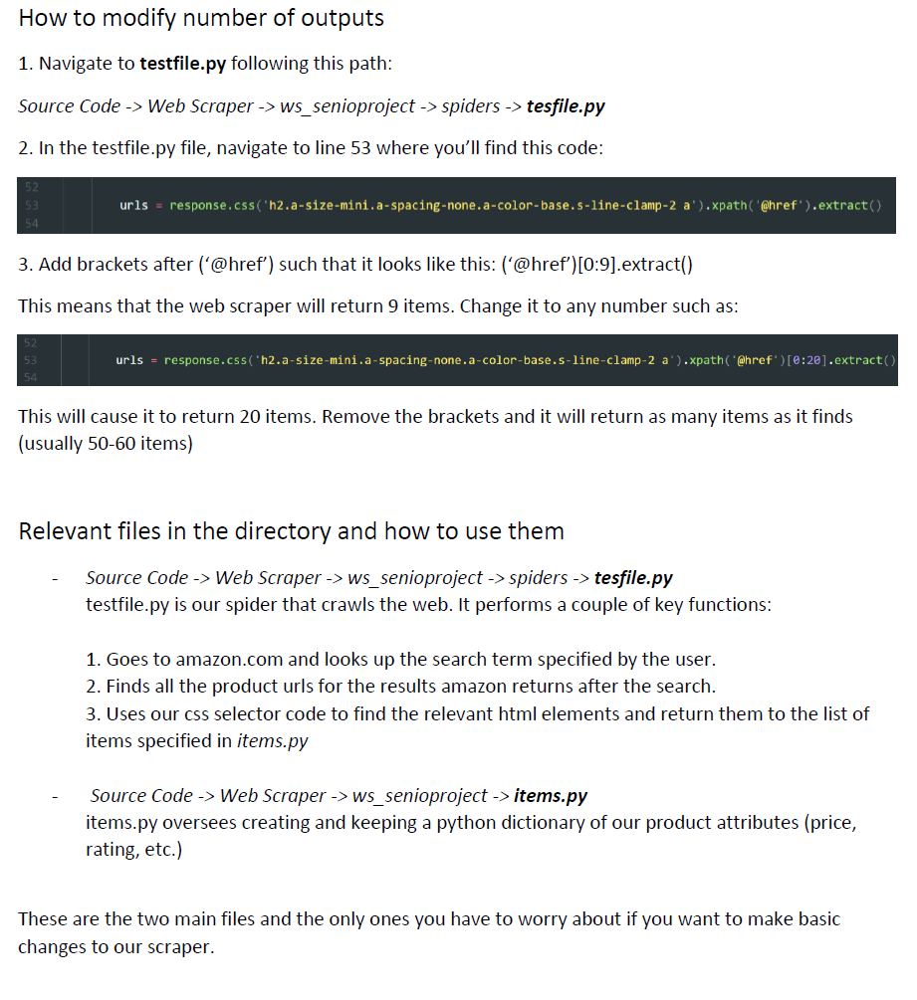

**Shortcoming/Wishlist**

We’ve had a very productive semester working on this project. While we consider our project to be immensely useful in its current state, we have a few additions in mind that we want to implement in future updates.

Our project was made possible through the guidance of the amazing team at the Mitre Corporation. Since our project was made for the purpose of serving as an addition to the Generation Ai Nexus, our work with them is not complete. The following additions have been planned to be made to the website following the April 27 deadline:

* A new page will be created with the title of “Data Cleaning”. This will allow for the data cleaning sections currently sitting in the “machine learning” page to be moved to this new page. The machine learning page will henceforth only include content specifically on machine learning.
* The “machine learning” page will be updated to include linear regression models. We will use our web scraper to collect additional data and store it in our website’s *dataset* folder. This new data will be used train a linear regression model that we will showcase on the website.

We believe these changes will allow our website to be more organized and more dynamic. Additionally, users will have at their fingertips information that can help them further their understanding of machine learning through powerful models.

# References

There were a multitude of sources we used to help us along the way. In this section we will be citing these sources.

**Flask**

*User’s guide*

<https://flask.palletsprojects.com/en/1.1.x/>

*Installation*

<https://flask.palletsprojects.com/en/1.1.x/installation/#installation>

*Jinja documentation*

[*https://jinja.palletsprojects.com/en/2.11.x/*](https://jinja.palletsprojects.com/en/2.11.x/)

**Anvil**

*Documentation*

<https://anvil.works/docs/overview>

**Machine Learning**

*Algorithms*

<https://www.analyticsvidhya.com/blog/2017/09/common-machine-learning-algorithms/>

*Definitions*

<https://www.technologyreview.com/2018/11/17/103781/what-is-machine-learning-we-drew-you-another-flowchart/>

*How to teach machine learning/tools*

<https://machinelearningmastery.com/start-here/>

**Web Scraping**

*What is web scraping?*

<https://www.webharvy.com/articles/what-is-web-scraping.html>

*Scrapy installation guide*

<https://docs.scrapy.org/en/latest/intro/install.html>

*Scrapy tutorial*

<https://docs.scrapy.org/en/latest/intro/tutorial.html>

*Selectors*

<https://docs.scrapy.org/en/latest/topics/selectors.html>